TOEFL
Primary
3
Speaking

Talk to your friend!
- It has four legs. What is it?
- He has a big, red nose. What is he?
Worksheet
3
Extra writing

- Look and write.

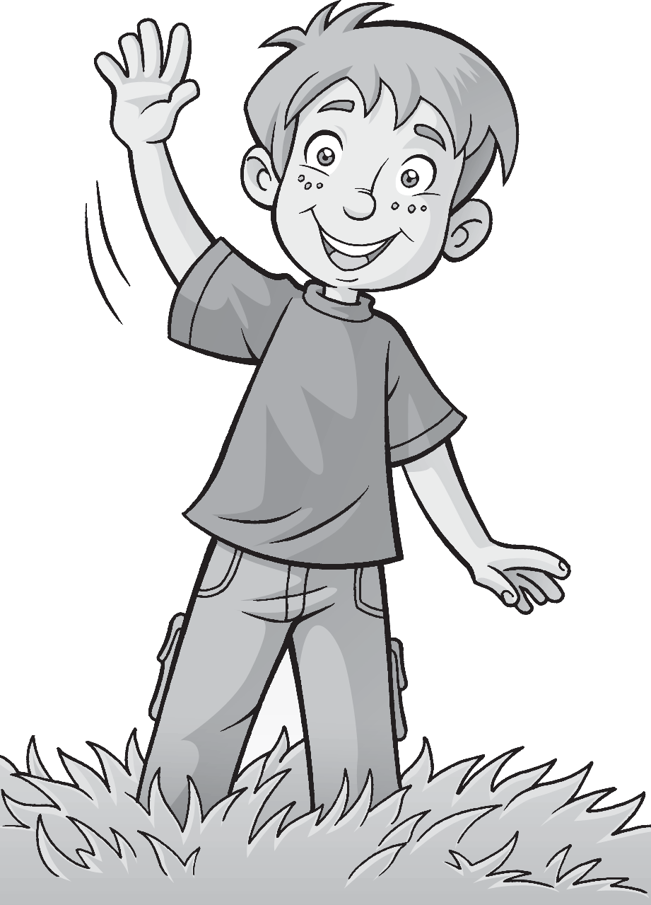4

1 hands

5
2

3 6

Write.
This is These are
  - These are 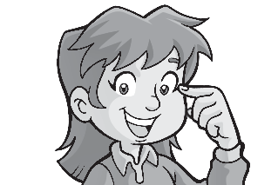 my eyes.
  - 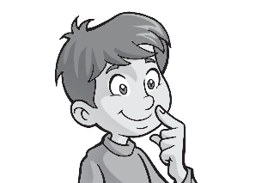my nose.
  - my face.
  - my hands.

Worksheet
3
Values
Take care in the sun
1 Write 3
or
7
.

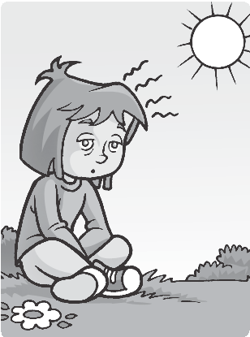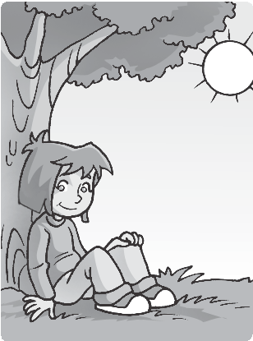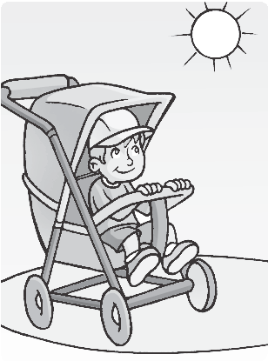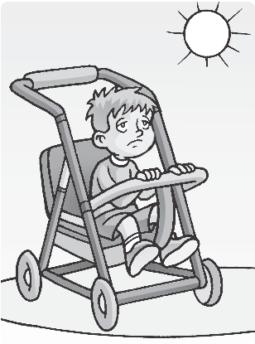
1

7
2
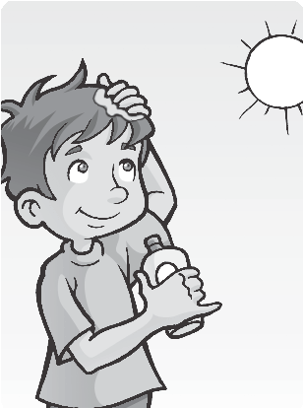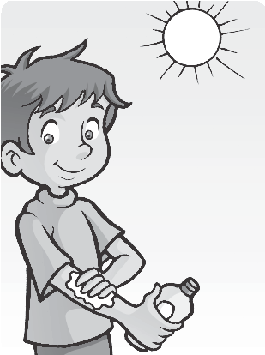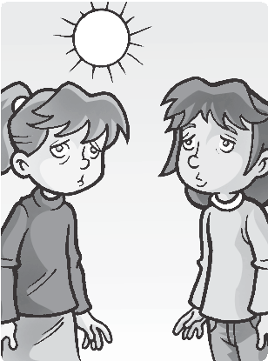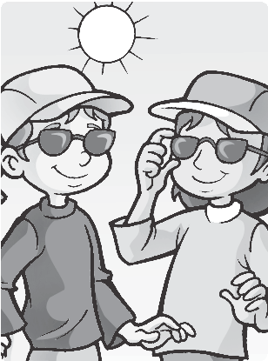
3
4

2 Draw a poster.
Remember!

- face

- eyes

- nose
- legs

- 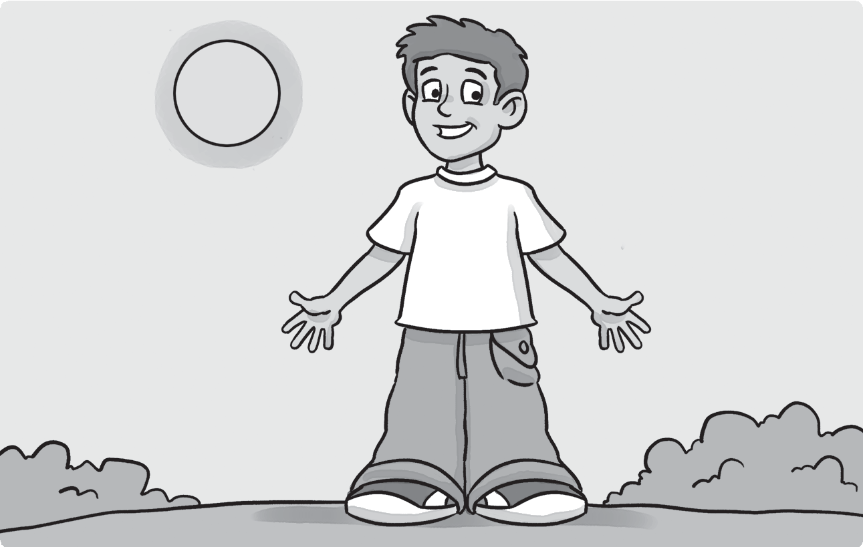arms

- hands

- fingers

2 Circle the correct word.
hand
1 one hands /

/ 6
- four kite / kites

3 three lion / lions 4 one faces / face
Test
3
Unit test
1 Match.
/ 6
5 two eye / eyes 6 five leg / legs
7 ten fingers / finger

Check (✔) the correct sentence.
/ 3
  - 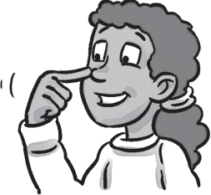This is my nose.
✔
These are my noses.

  - This is my eye. These are my eyes.

  - This is my finger. These are my fingers.

  - These are my faces.
This is my face.
/15

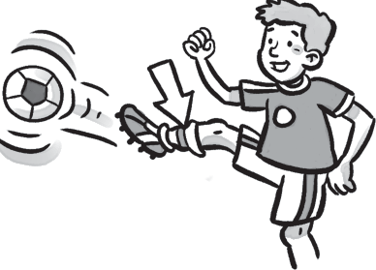
5
4
4
3
Test
Summative test 1

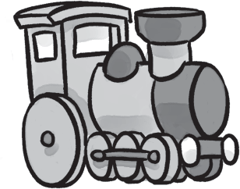Match.
c
a
c
/ 4
  - eraser
  - train
b
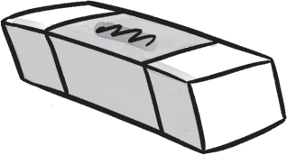
  - bike
  - window
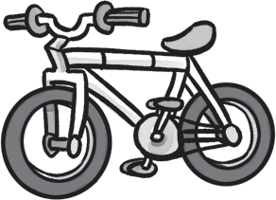
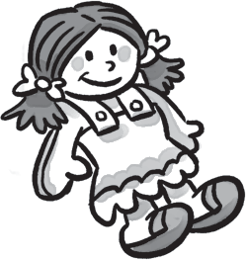
  - doll
e
d

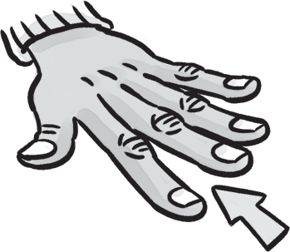
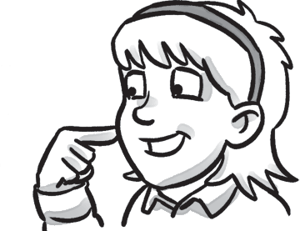Look and write.
2
/ 4
1
1

2  3 |  | f |  | c
 |  | i
 |  | n |  | s
l |  | g
 |  | e
5 | a | r
 |  | s

3 Match.
- How are you?  - Is this your pen? | c | a  b | It’s red.  No, I’m not.
3 What color is the car? |  | c | I’m fine.
4 Are you five? |  | d | It’s a pencil.
5 What’s this? |  | e | Yes, it is.

/ 4

- Look and write.
is These This your

These are my eyes.

/ 3

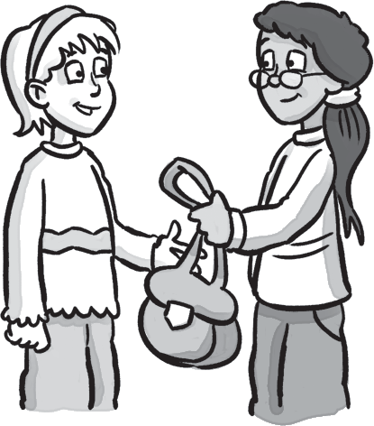This is
2

bag.

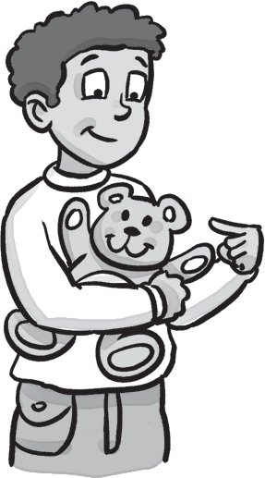
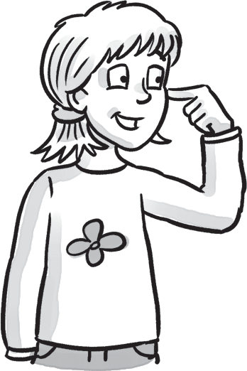This my teddy bear.
1
3
is my bike.

/25

Summative test 1

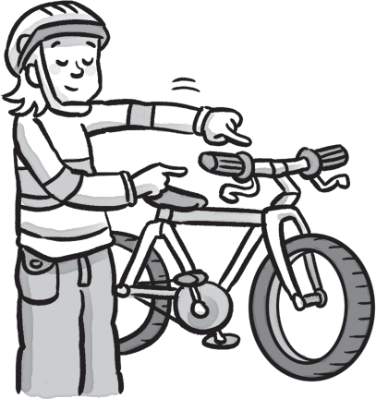Circle the correct first letter.
4
/ 5

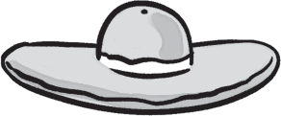1 f b 2 a e i
h

3 b d f 4 c i k 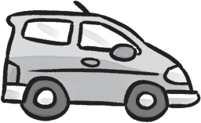
5 i b j 6 g k j

Listen and check (✔) the sound you hear. 10
/ 5
1 d b k
✔

2 a | j | f
3 i | e | a
4 l | b | g
5 h | j | l
6 g | p | r

Reading

Read and number.

  - 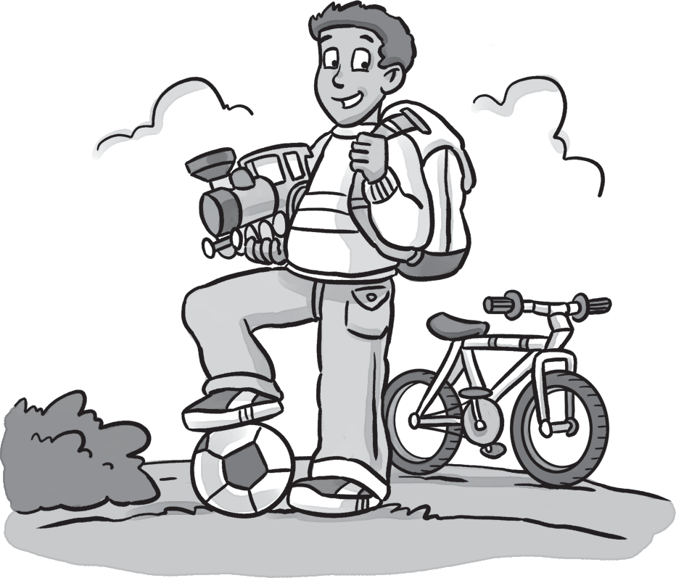My name’s Leo. This is my ball. It’s black and white.
1
  - This is my school bag. It’s white.
  - This is my bike. It’s white.
  - This is my train. It’s gray. My favorite color is gray.

Read again and write T (true) or F (false).
/ 4
1 My school bag is black. F 2 My ball is green. 3 My favorite color is gray. 4 My bike is white. 5 My train is blue.

Skills test 1
Writing

Count the words in each sentence. Circle.
/ 4

1 How are you? | 1 | 2 | 3 | 4
2 Is this your doll? | 1 | 2 | 3 | 4
3 I’m fine. | 1 | 2 | 3 | 4
4 These are my eyes. | 1 | 2 | 3 | 4
5 No, it isn’t. | 1 | 2 | 3 | 4
- Complete the sentences.
/ 4
This is These are
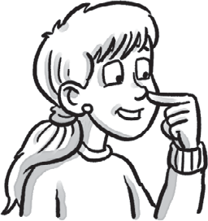
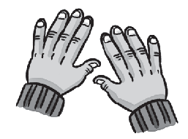
1
2
These are my hands. my nose.
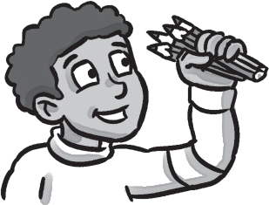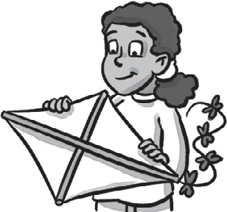
3
4
my pencils. my kite.
5
my bag.

Speaking

Ask and answer.
1 How are you? 2 How old are you?
/ 6
I’m fine.
3 Are you 8? 4 What color is your school bag?
5 What’s your favorite color? 6 What’s your favorite toy?
7 What color are your eyes?
/30

