Look and write.
3
4
 |  |  |  |  | 3
 |  |  | 1
 |  |  | f |  | 2
 |  |  | i
 |  |  | r
 | 4 |  | e
 |  |  | f
 |  |  | i
 |  |  | g
 |  |  | h
 |  |  | t
 |  |  | e
 | 6 |  | r

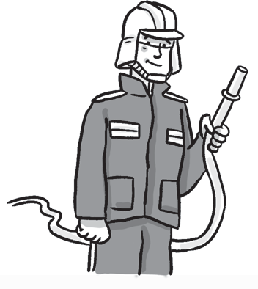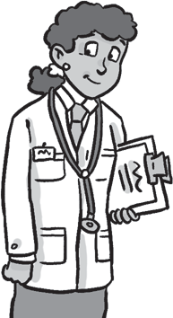
1
2

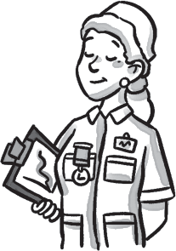
5
6
5

- Complete the sentences.
1
2

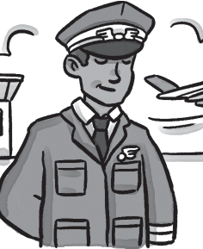 She’s a teacher.
Worksheet
4
Extra writing

3

a pilot.
a doctor.

4

a nurse.

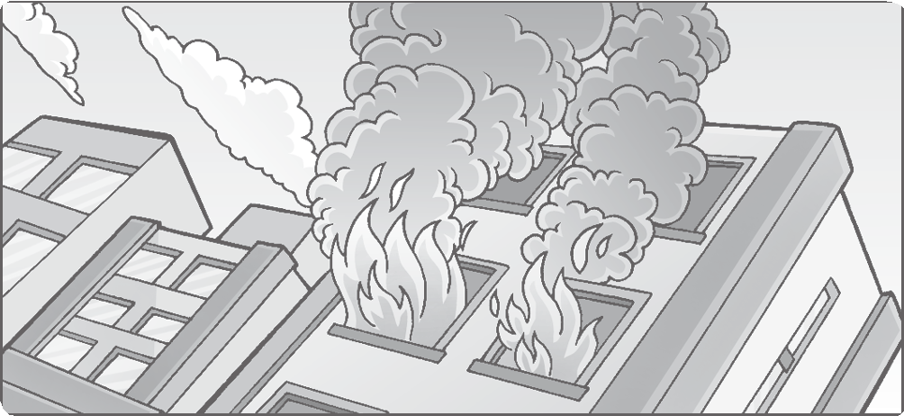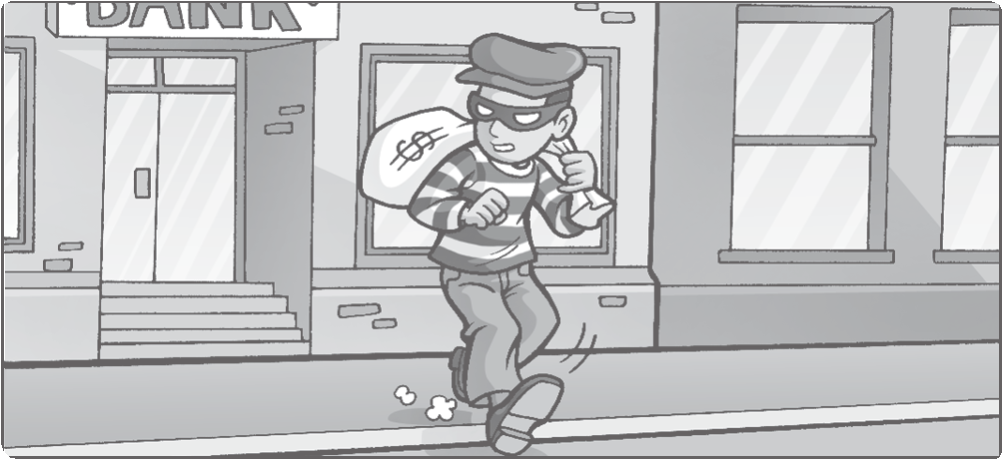Who do we need? Look and circle.
2
1
doctor / police officer
firefighter / pilot
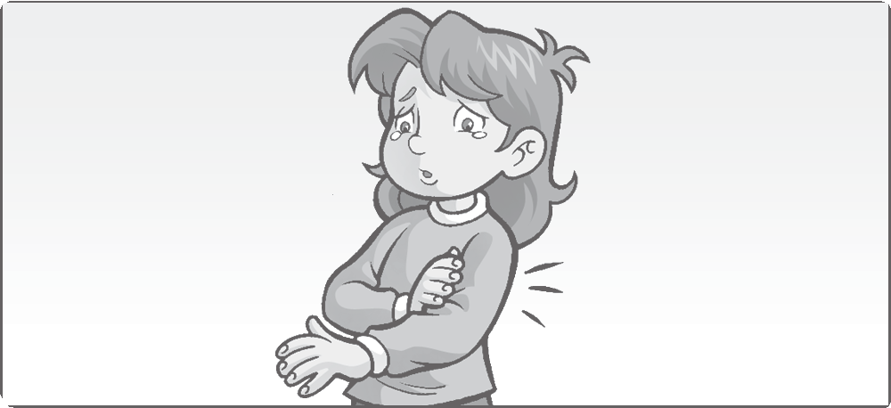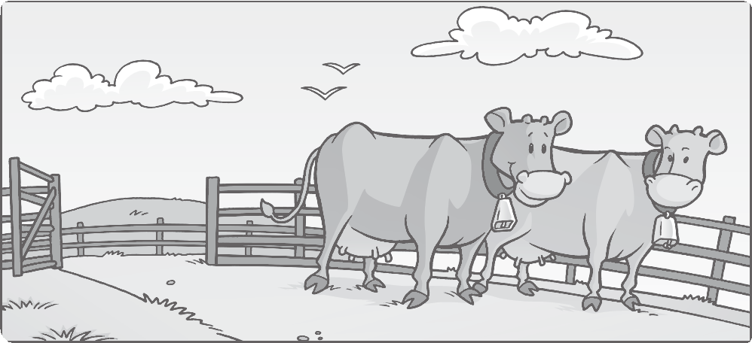
3
4

student / doctor

What do you want to be? Draw.
farmer / nurse

Worksheet
4
Values
People who help us

/ 5

1 teacher
3 doc
5 fire

2 Look and write.
2 police
4 far
6 stud

/ 4

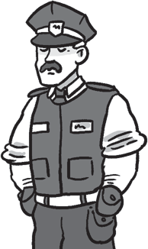
1
2
3
4
5
eolipc ercifof dcotor dnettus nusre lotpi
police officer

Order the words.
/ 3

1 Is he a pilot?
he
Is
pilot?
a
2
a
she
nurse?
Is
3
teacher?
a
Is
she
4
a
She’s
firefighter.
/ 3

Look and complete the sentences.
2

Is she a pilot? No, she isn’t.
1

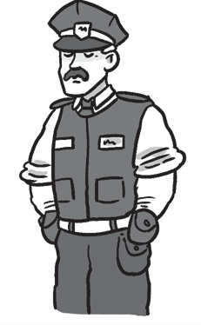Is a teacher? Yes, is.
3
4

Is a firefighter? Yes, is.

Is a police officer? Yes, is.

Test
4
Unit test
1 Find and write.
cher mer fighter officer tor ent
/15

