TOEFL
Primary
5
Reading

1 Look at the picture. Circle A, B, or C.
- It’s a frisbee.
Example
- It’s a tree.
It’s a seesaw.
(C)

- (A) It’s a pool.
- It’s an ice cream.
- It’s a goal.

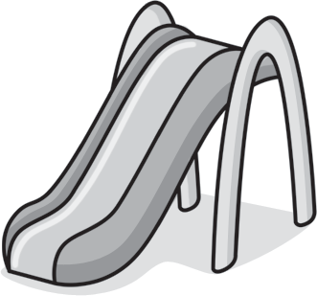
- What is in the park?
  - A slide
  - Two seesaws
  - Two boys

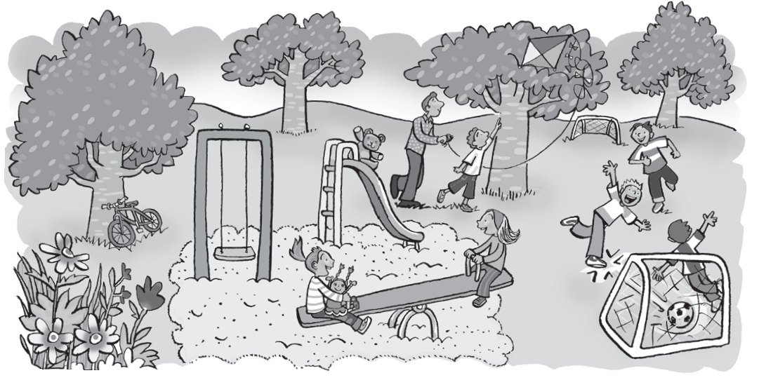
- Where’s the ball?
  - It’s in the goal.
  - It’s in the tree.
  - It’s on the slide.

- Where’s the bike?
  - The tree is under the bike.
  - The bike is under the tree.
  - The bike is on the tree.

TOEFL
Primary
Reading

Look at the picture, read, and guess. What is it? Circle A, B, or C.
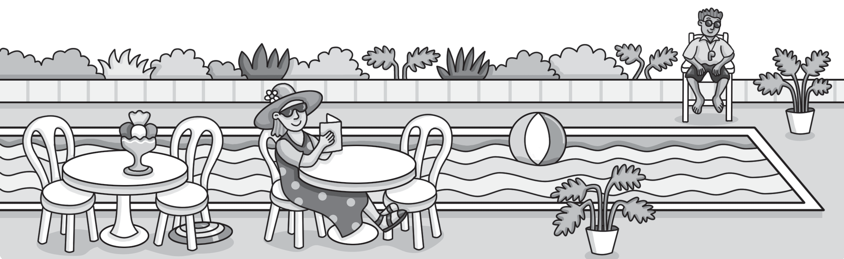

It’s a toy. It’s in the pool. What is it?
Example
It’s a ball.
(A)
- It’s a frisbee.
- It’s a seesaw.

  - It’s a toy. It’s under the chair. What is it?
    - It’s a table.
    - It’s a frisbee.
    - It’s an ice cream.

  - They’re black. They’re on the man’s face. What are they?
    - They’re sunglasses.
    - They’re shoes.
    - They’re shorts.

  - It’s nice and cool. It’s on the table. What is it?
    - It’s a pool.
    - It’s my mom.
    - It’s an ice cream.

TOEFL
Primary
Reading

Read and answer the questions. Circle A, B, or C.
I’m Nam. This is my house. I can see the park from my window. I can see a slide and a goal in the park. My friend, Vinh, is in the park. He is on the slide. Vinh has a dog. It is under the slide. There’s a pool in the park, too. I can see a boy in the pool. He is my brother. I like playing in the park!

What is the boy’s name?
Example
(A) nam Nam
(B)
(C) Vinh

- What can Nam see?
  - He can see a slide, a pool and a goal.
  - He can see a girl, a pool and a slide.
  - He can see a pool, a boy and a cat.

- Where is Vinh?
  - He is under the slide.
  - He is in the pool.
  - He is on the slide.

- Where is Nam’s brother?
  - He’s in the house.
  - He’s in the pool.
  - He’s in the goal.

Worksheet
5
Extra writing

Circle the odd-one-out. Write.
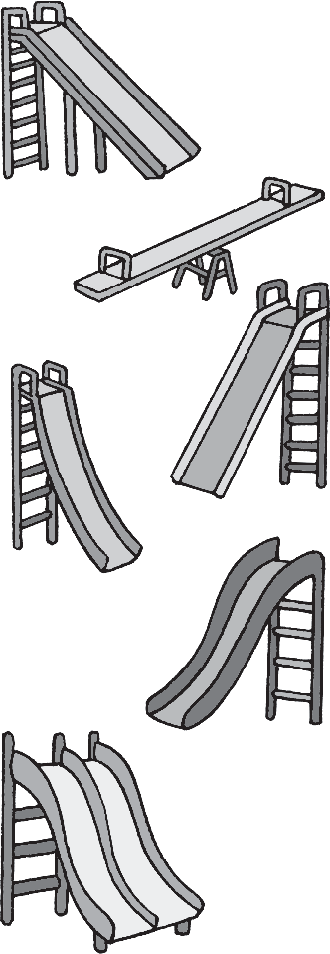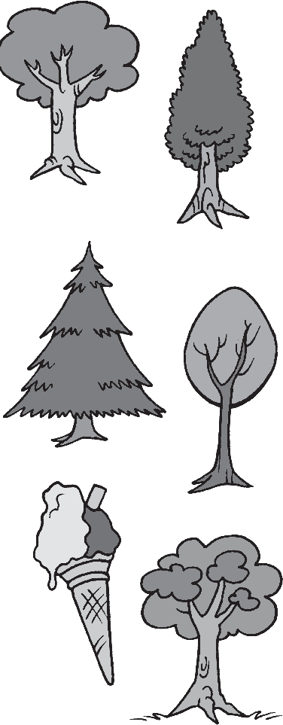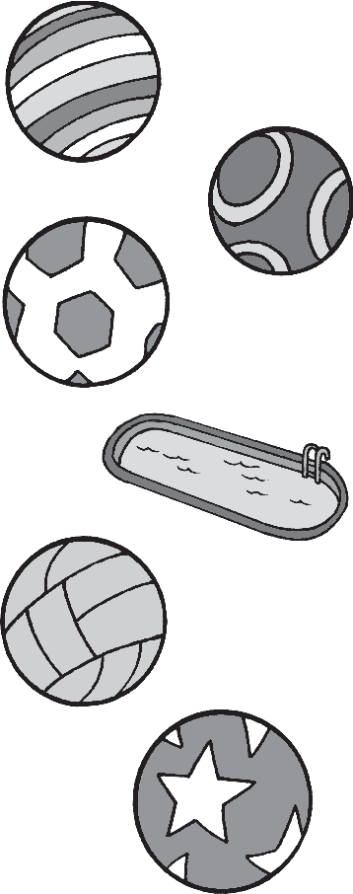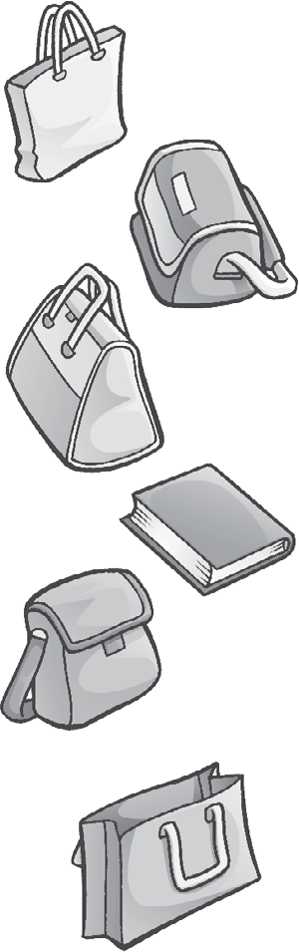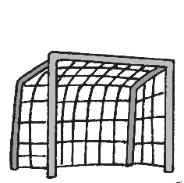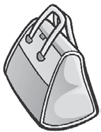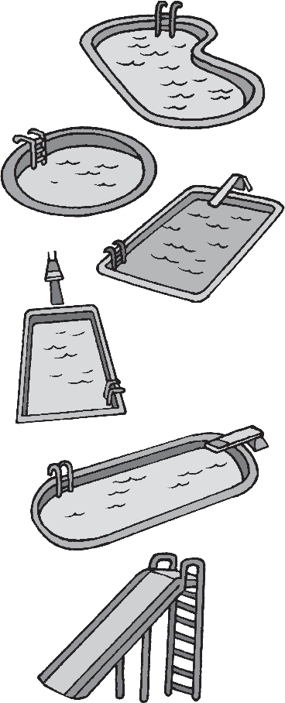
1
2
3
4
5
seesaw

Look and write.

in on under

  - 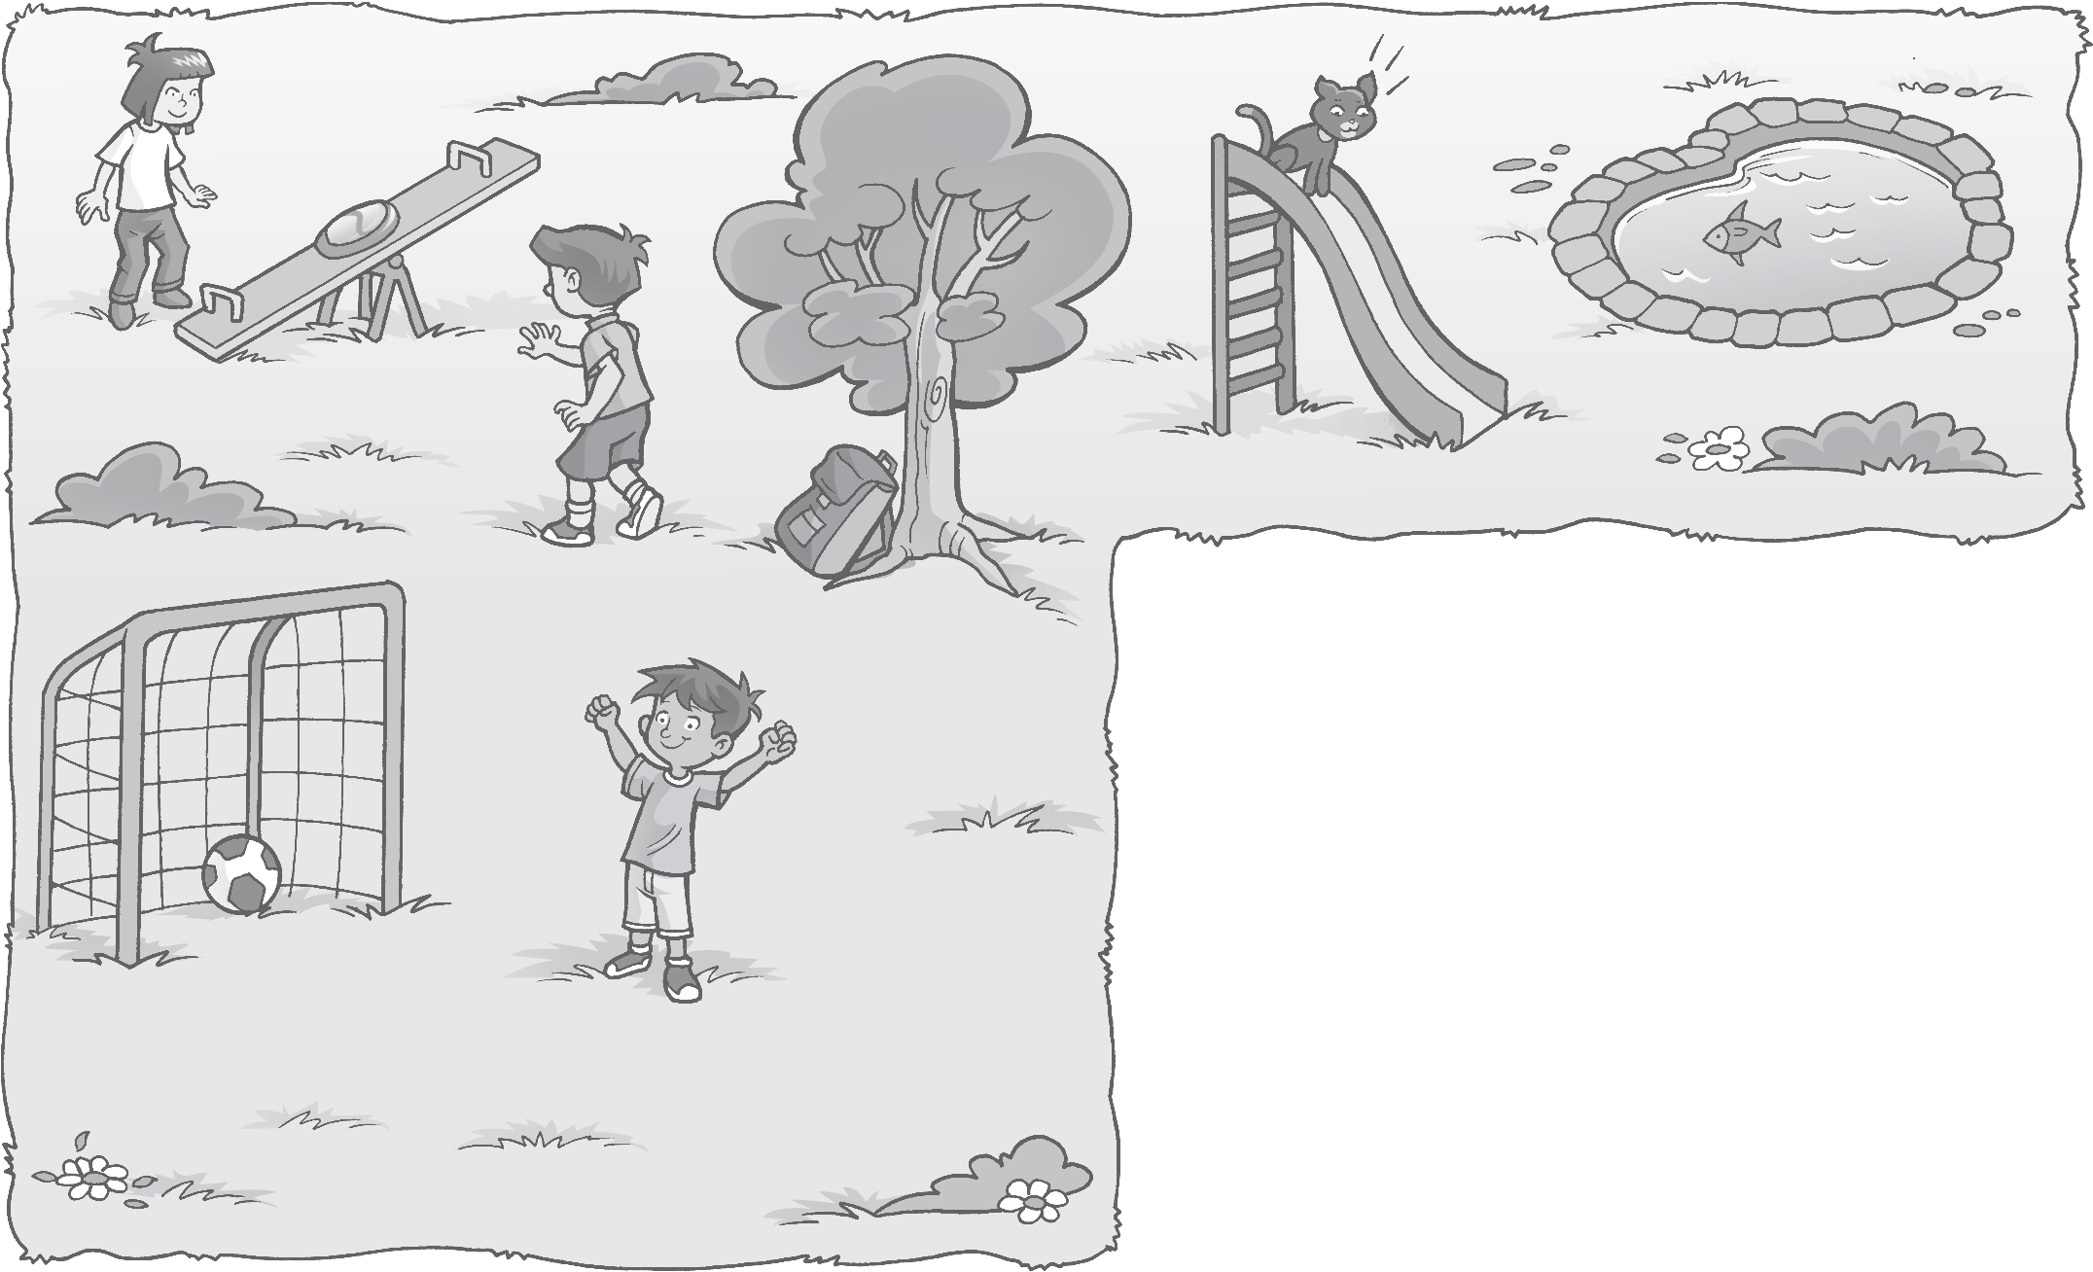The frisbee is on the seesaw.
  - The ball is the goal.
  - The bag is the tree.
  - The cat is the slide.

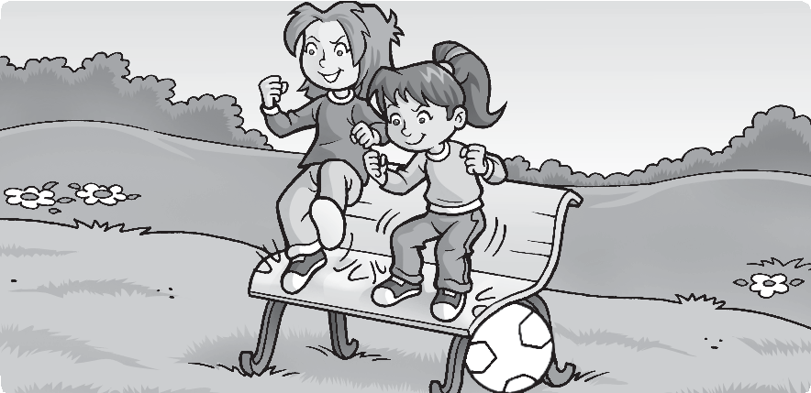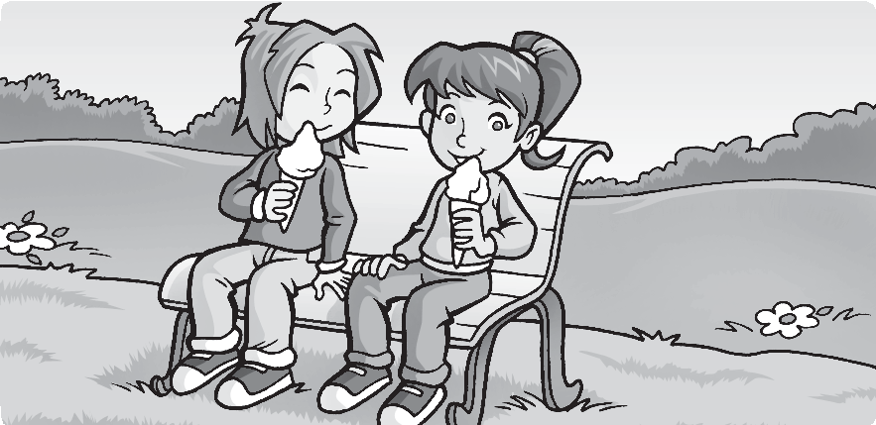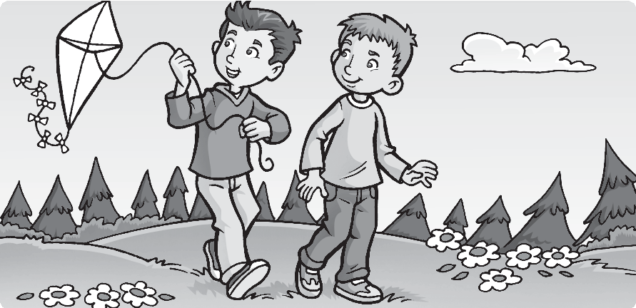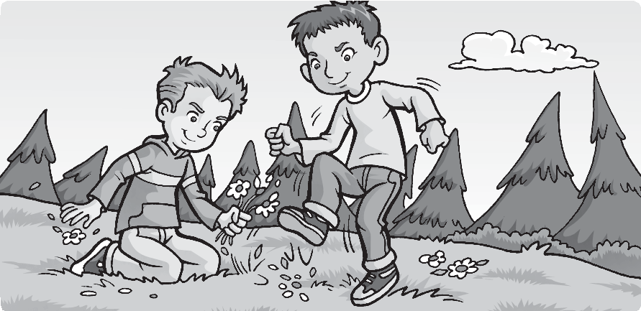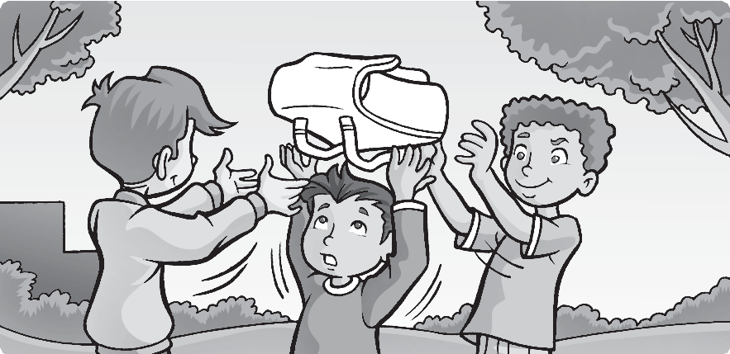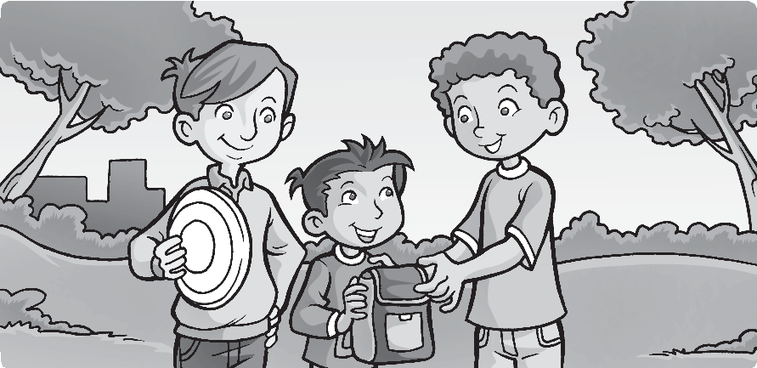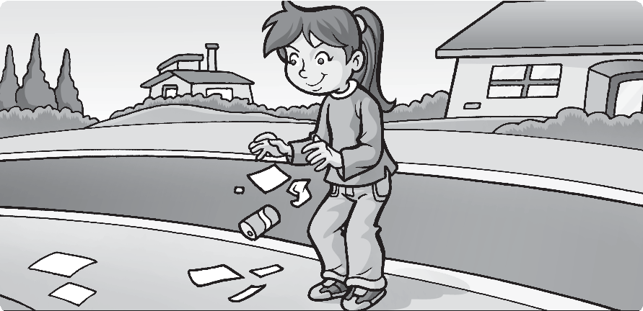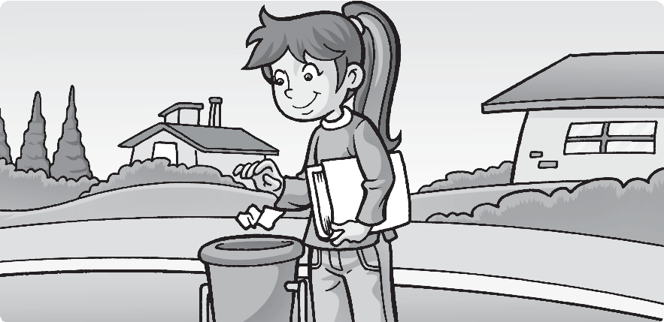Write or .
1
7
2
3
4
3
7

- Color.
Worksheet
5
Values
Take care in the park
A blue ball.
An orange bag. A red frisbee.

A yellow kite. A green book. Pink ice cream.

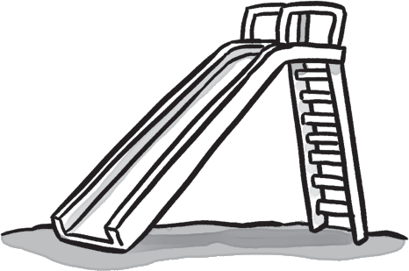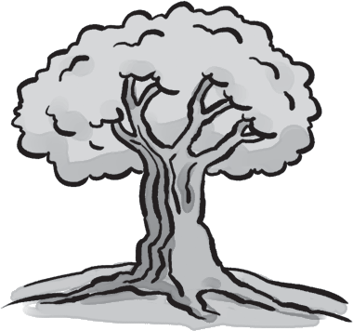
1
2
3
4
5

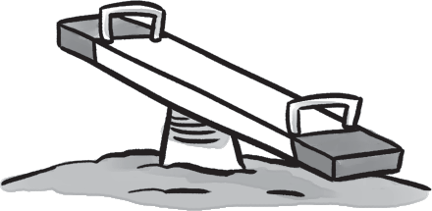
slide
✔
tree seesaw
sofa
ice cream

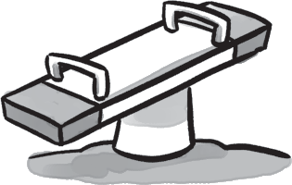
2 Complete the words.
/ 4

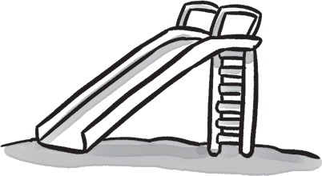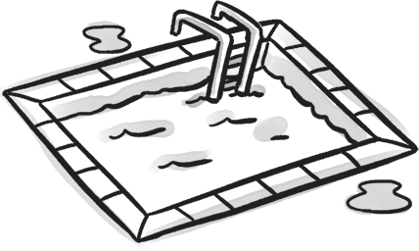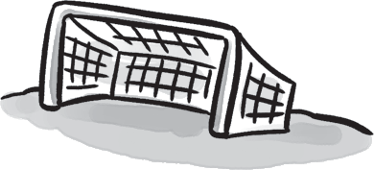

1 fr i s bee 2 s i e 3 p l
- g l
5 s s

Test
5
Unit test
1 Write ✔ (yes) or ✘ (no).
/ 4
- Complete the sentences with in, on, or under.
/ 4
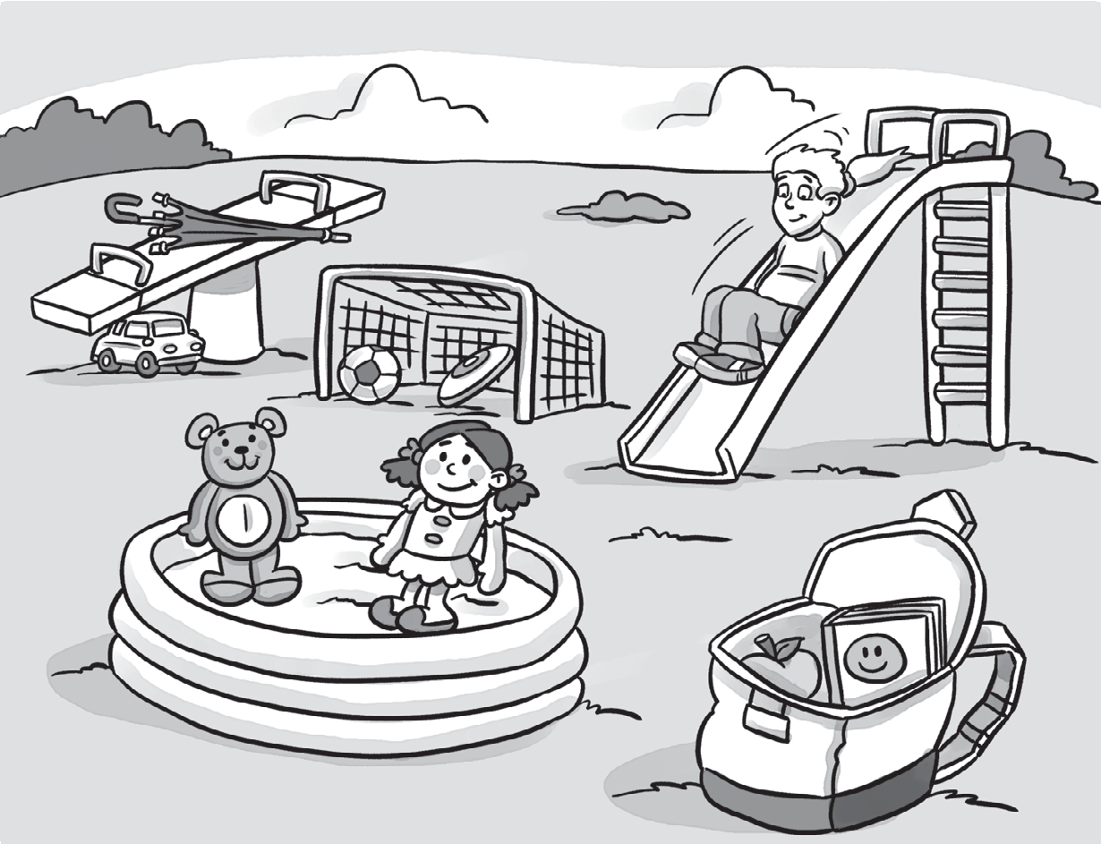
  - The ball is in the goal.
  - The umbrella is the seesaw.
  - The teddy bear is
the pool.
  - The girl is the slide.
  - The car is the seesaw.

Look at the picture again and complete the sentences.
/ 3
- Where’s the frisbee? It’s in the goal.
- the book? in the bag.
- the doll? .
- the apple? .
/15

