TOEFL
Primary
6
Speaking

- Write.
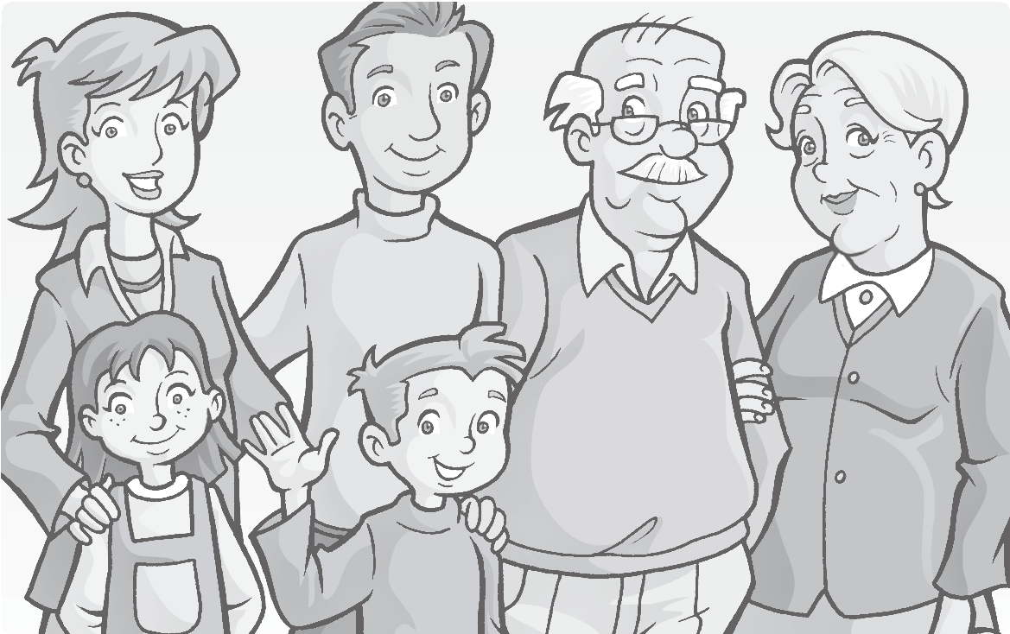
1
2
3
4
5
6

1 mom
4 g

Look and write.
2 d
5 s
3 g
6 b

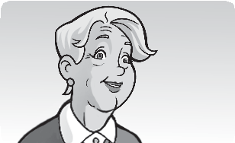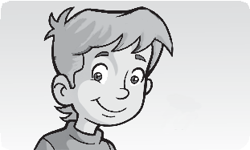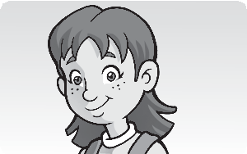This is my grandma’s book. This is my b train. This is m s kite.
1
2
3
This m car.
4

Worksheet
6
Extra writing
5
d bike.

Worksheet
6
Values
My family
1 Look and draw.

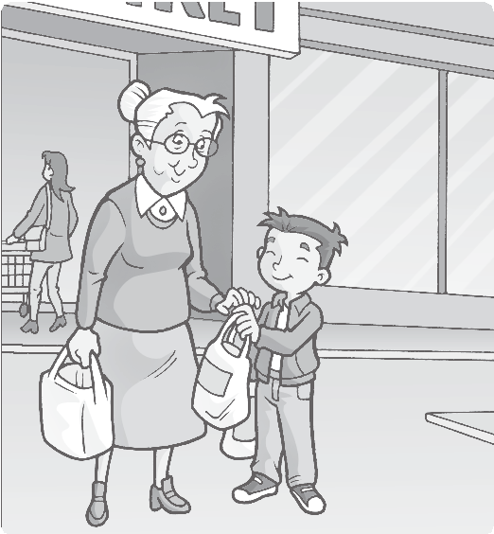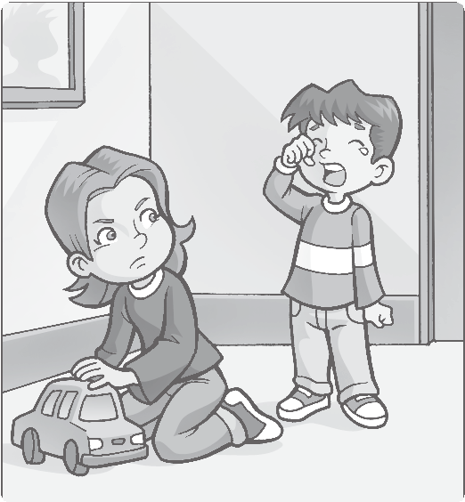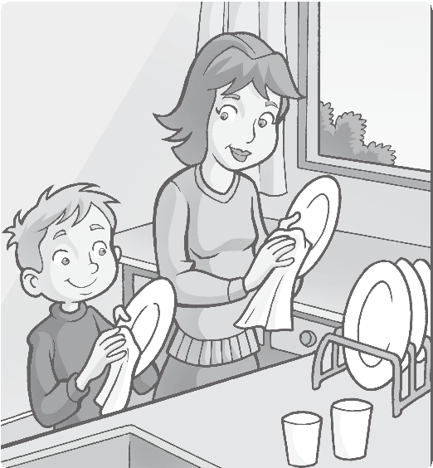
1
2
3
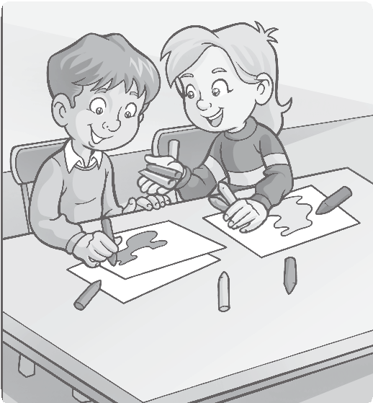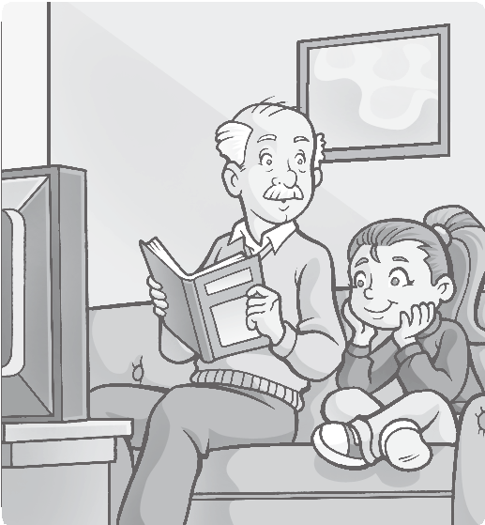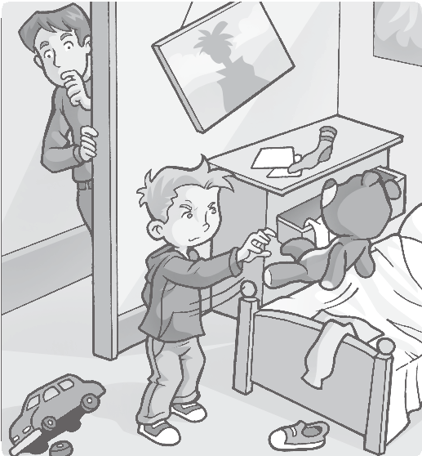
4
5
6

2 Draw you and your family.

- Circle the correct word.
1 mom /
dad
3 brother / sister

Write.

/ 3
2 mom / grandpa
4 grandma / grandpa

/ 5

ther pa ma ter sin om

1 | grandma | 2 | grand
3 | cou | 4 | sis
5 | bro | 6 | m

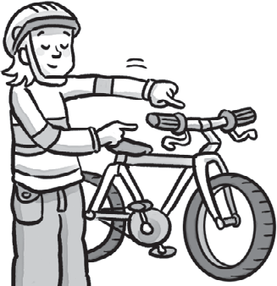
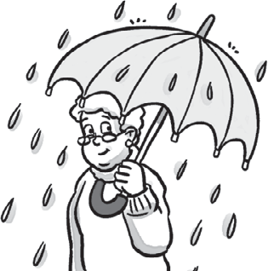Check (✔) the correct sentence.
1
2
3
/ 3
4

1 It’s Mom’s book.  It’s Dad’s book. | ✔ | 2 | This is my sister’s bike.  This is my brother’s bike.
3 It’s Grandma’s umbrella. It’s Grandpa’s umbrella. |  | 4 | This is my cousin's hat. This is my grandma's hat.

- Match and write.
Test
6
Unit test
  - It’s Sally’s bag.
  - It’s frisbee. 3 ball. 4 pen. 5 kite.

/ 4

Jenny Tom Sally Frank Bob
/15

Circle the correct word.
/ 3
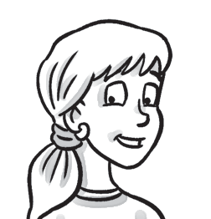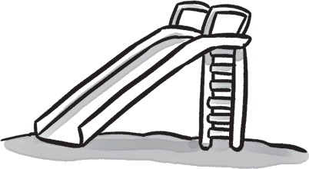
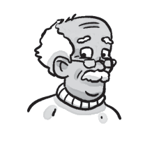
1 / dad 2 slide / frisbee 3 grandpa / brother 4 goal / pool
mom

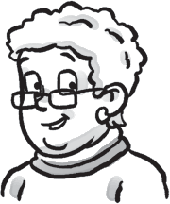Write and match.
  - t h e r b r o brother

  - b e e f i r s 3 e e r t 4 d n g r a m a 5 m e r f a r

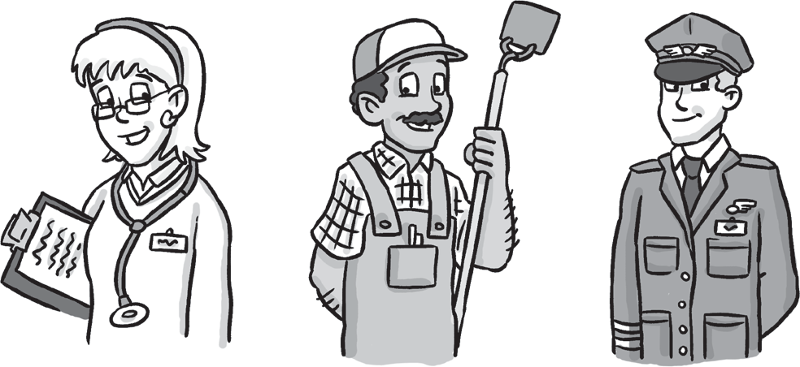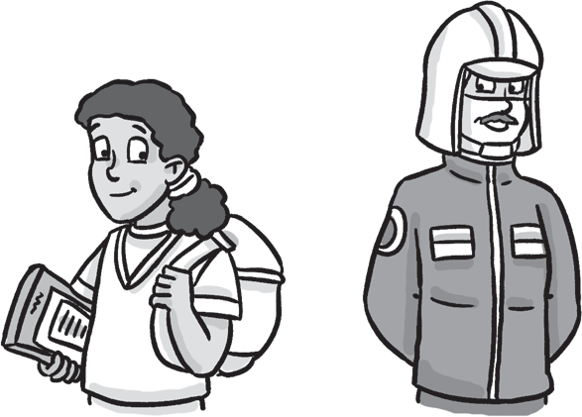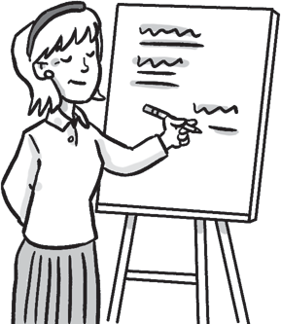Look and circle.
1
2
3

/ 4

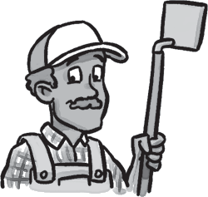

/ 5

4 5 6

Test
Summative test 2

    - Is she a pilot? Yes, she is. / No, she isn’t.
    - Is he a farmer? Yes, he is. / No, he isn’t.
    - Is he a doctor? Yes, he is. / No, he isn’t.
    - Is she a nurse? Yes, she is. / No, she isn’t.
    - Is she a student? Yes, she is. / No, she isn’t. 6 Is he a firefighter? Yes, he is. / No, he isn’t.

Complete the sentences with in or under.
/ 3
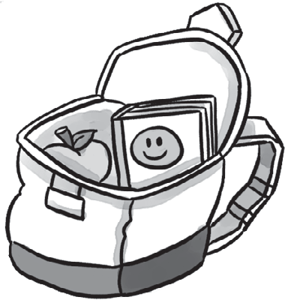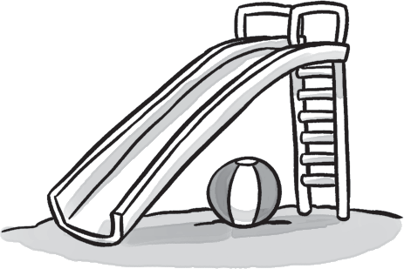
1
2
The apple is in the bag. The ball is the slide.

My brother is the pool.
3
4

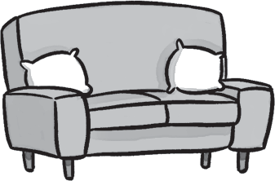Match.
- o
- s
- z
- p
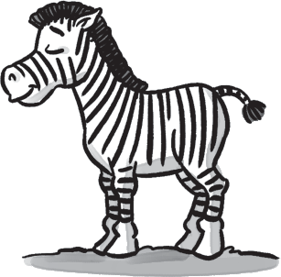
- u
- y
- x
The apple is the hat.

/ 6

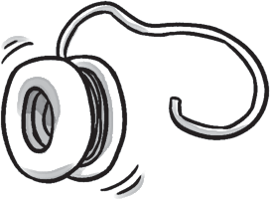

Summative test 2

Reading
- Read and write the name.
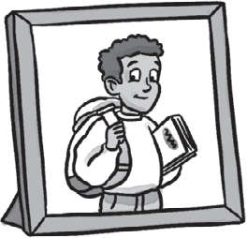
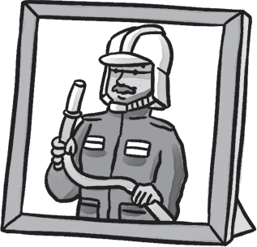
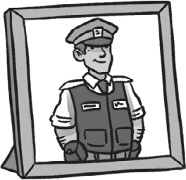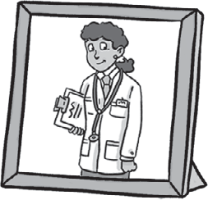
a
b
c
d
  - This is my brother. He’s a student.
  - This is my cousin. He’s a police officer.
/ 3
brother

  - This is my dad. He’s a firefighter.
  - This is my mom. She’s a doctor.

Read again and write T (true) or F (false).
/ 3
- Ana’s dad is a firefighter. T
- Ana’s cousin is a farmer.
- Ana’s brother is a student.
- Ana’s mom is a nurse.

Copy the sentences in your best handwriting.
/ 4
  - He’s a doctor. He’s a doctor.
  - Where’s the ball?
  - It’s in the goal.
  - This is my dad.
  - Yes, he is.

Look and write.
/ 5

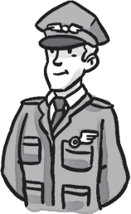
otpil
1
pilot

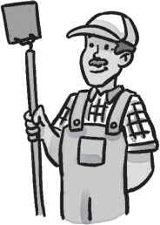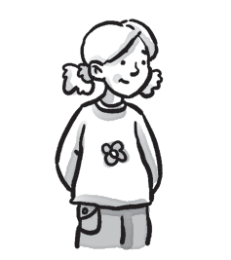merfar
3
5
magrdan

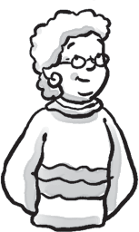
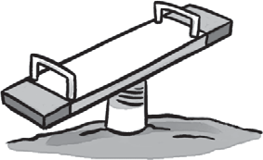eewass
4
2

sisert
6

Speaking

What’s this? Say the words.
codrot

/ 6

Writing
Skills test 2
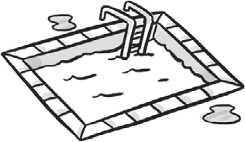
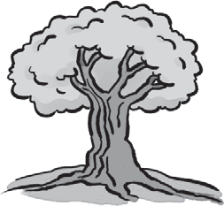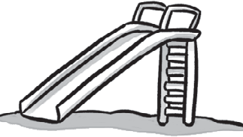
3
4
5
6
/30
1
2

