# 1 Write and match.

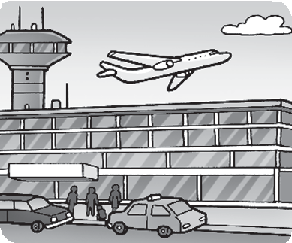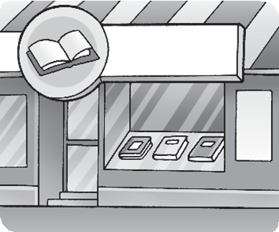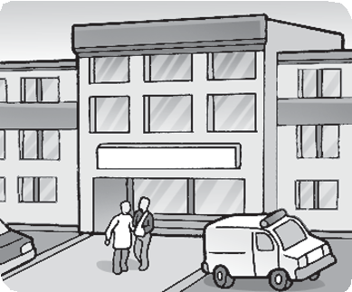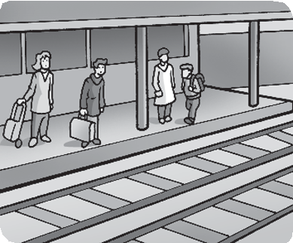

1. portair *airport*

*d* **a b**



**Worksheet**

7

Extra writing

1. toers
2. astiont

## c d

1. psotialh

# 2 Look and write.

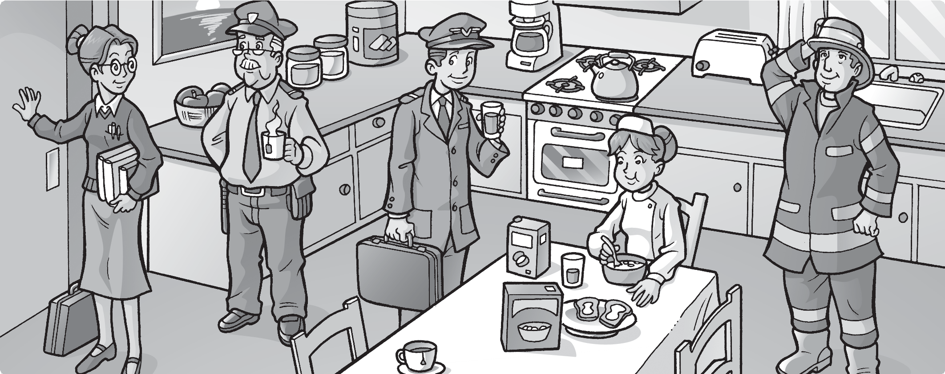

**1**

**2**

**3**

**5**

**4**

1 Does your mom work in a store? *No, she doesn’t. She’s a teacher*. 2 Does your grandad work in a zoo? 3 Does your brother work in an airport? 4 Does your sister work in a station? 5 Does your dad work in a hospital?



**Worksheet**

7

Values

All jobs are important

# Look and match. Who helps?

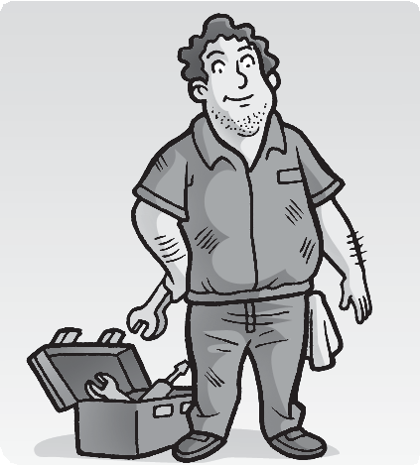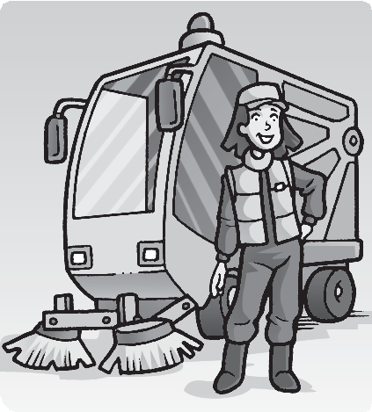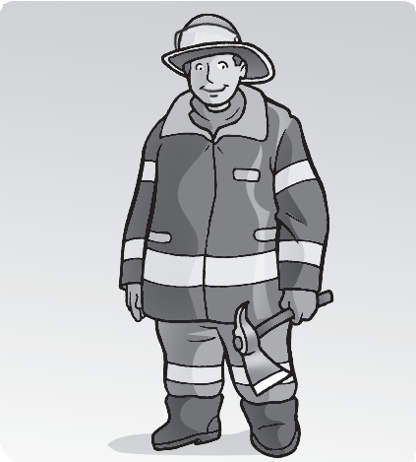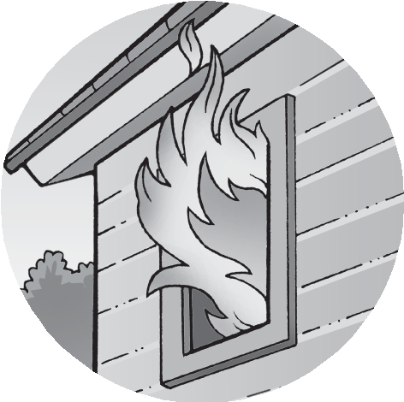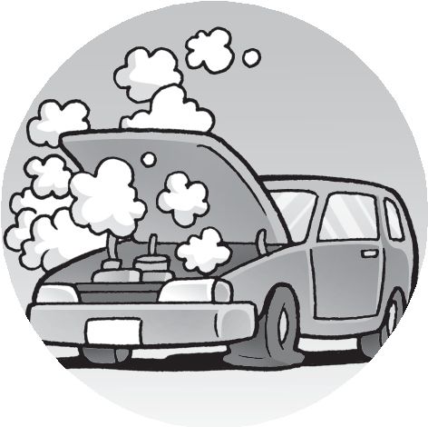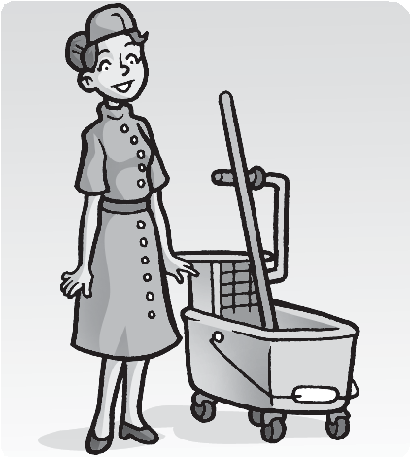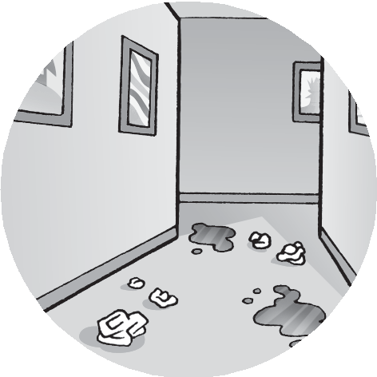

**1**

**2**

**a**

**b**

**3**

**4**

**c**

**d**



**5**



**6**



**e**

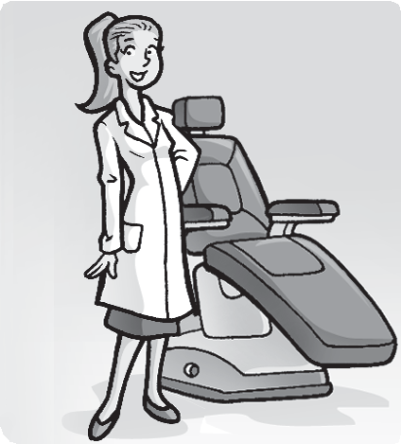

**f**

1. **Draw another important job.**



1. 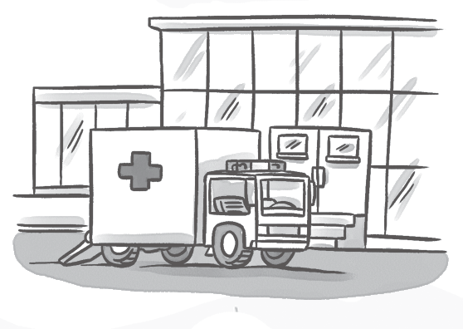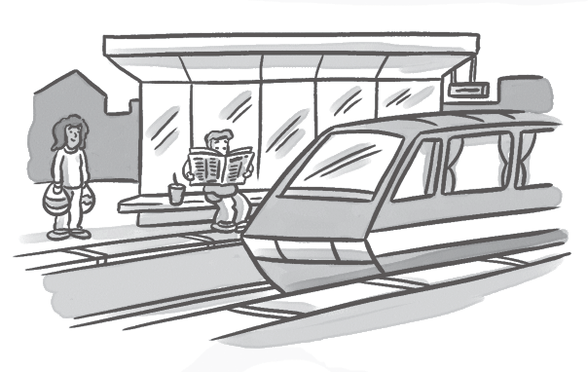**Complete the words.**

**/3**



1 a*irport* 2 z 3 h 4 s

# Circle the correct word.

**/4**



**1**

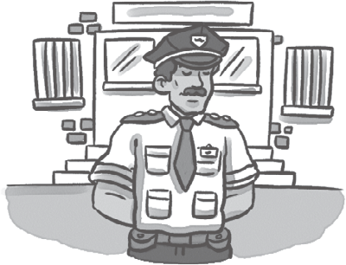

**2**



**3**

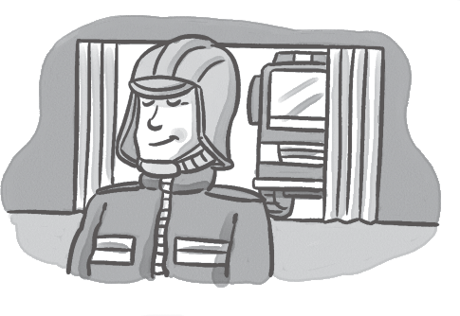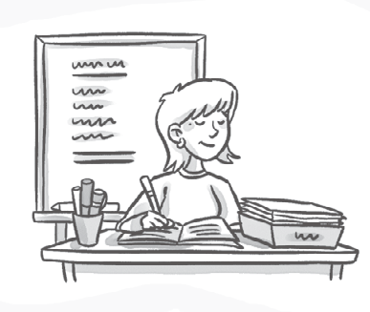

**4**

**5**

1 She works in a *zoo / store.* 2 He works in a police *station / hospital*.

3 She works in a *bank / station*. 4 He works in a *store / fire* station.

5 She works in a *school / zoo*.

# Complete the sentences and match.

**/8**

## a



*works in a store.*

*Where does your dad work?*

## b

*your mom work*

*in a zoo?*

## c

*your brother*

*at an airport?*

*/15*

*, he does.*



**4**

*Where your*

*sister work?*



**d**

*No, she .*

*He in a bank.*



**Test**

7

Unit test