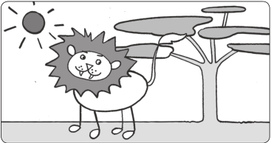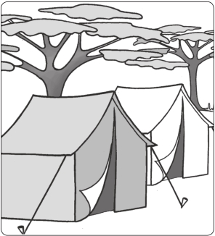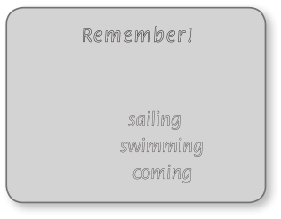

Worksheet Extra writing 4−6

1 Read and circle the proper nouns.

My name is Ellen. My favorite movie in the world is Born Free. It’s a movie about a lion in Kenya. A woman called Joy Adamson helps a lion to live free in Africa. My dream is to go to Africa one day and see the lions living free.

2 Read and complete the sentences.

Remember!

Sometimes the
spelling changes:
Ellen’s dream is 1 coming (come) true! She is 2

(go) to Africa to see lions 3 (live) in the wild.

It’s so exciting, she says. I can’t wait to see real lions.

sail sailing swim swimming
come coming

Today, Ellen and her family are 4 Nairobi, but they aren’t 5

(fly) to

(stop) in Kenya.

They are 6 (get) on a bus and

7 (drive) to Tanzania. Ellen is happy.

Tanzania has a famous national park, she says. You can see lots of lions there.

They are 8 (sleep) in tents in the national

park. Ellen loves camping. I’m not 9 (share)

a tent with my mom and dad, she says. My sister and me have a tent just for us. Ellen is very happy on her great adventure!

3 Look again and underline what Ellen says.

4 Copy what Ellen says and write the quotation marks.

1 “It’s so exciting,” she says. “I can’t wait to see real lions.”

2

3

Family and Friends Special Edition Grade 5 Assessment and Resource Portfolio Unit 6
35
© Oxford University Press
Permission granted to reproduce for instructional use.

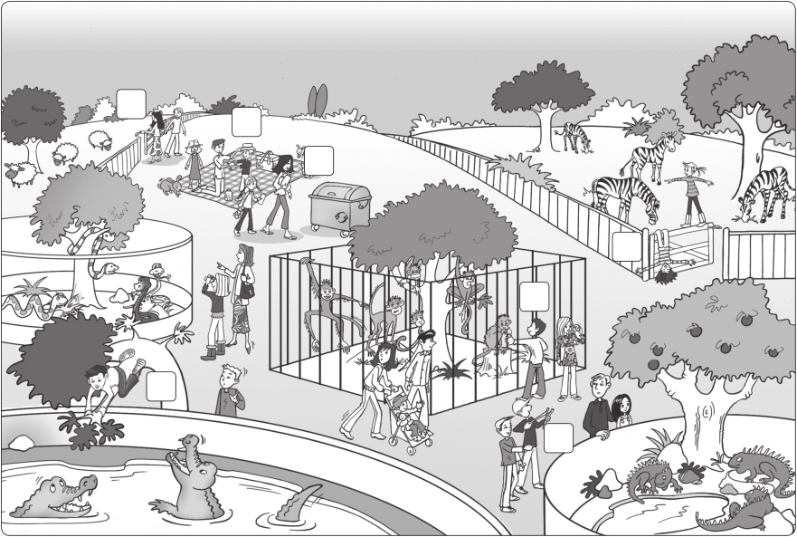

Worksheet
Values 4−6 Respecting nature

1 Look and write the numbers.

1 2

3

4

6

5

7

He’s climbing a tree.

They’re playing on the gate. They’re putting on sunscreen. They’re shutting the gate.
5
He’s throwing stones at the tree.

He’s touching the animals.

She’s putting the litter in the garbage can.

2 Complete the table.

Good

Bad

putting the litter in the garbage can

Family and Friends Special Edition Grade 5 Assessment and Resource Portfolio Unit 6

36

© Oxford University Press
Permission granted to reproduce for instructional use.

Worksheet
Values 4−6 Respecting nature

1 Match the beginnings and ends of the rules.

1 Climbing trees is dangerous. b a The animals can bite you.

2 Put your litter in the garbage can. b You can fall and hurt yourself.

3 Wear a sun hat! c You can break them or hurt yourself.

4 Playing on gates is bad. d Animals can’t eat it.

5 Hurting animals is not kind. e You can get sunburned.

6 Shut the gate behind you. f The animals can get out.

7 Touching the animals is dangerous. g They can get angry or scared.

2 Write and draw. Make a poster about respecting nature.

Respect nature!

Family and Friends Special Edition Grade 5 Assessment and Resource Portfolio Unit 6
37
© Oxford University Press
Permission granted to reproduce for instructional use

