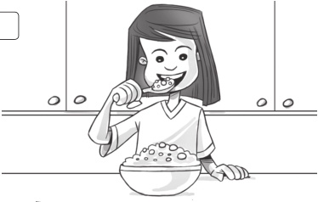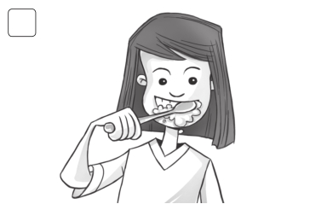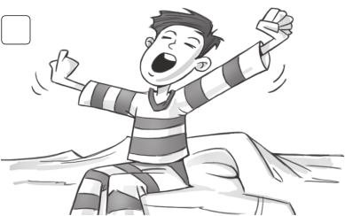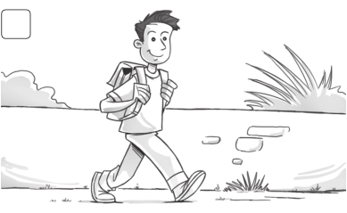

Test 6 Unit test

1 Circle. /3

1 2

have breakfast / get dressed get up / brush my teeth

3 4

have a shower / brush my teeth catch the bus / walk to school

2 Complete. every day First every day Finally Next /4

I get up at seven o’clock 1 every day . 2 , I have a shower. Then I

get dressed. 3 , I brush my hair and have breakfast. 4 ,

I brush my teeth. Then I go to school. But I don’t go to school 5 .

3 Underline the correct words.

Tim What time 1 do you / does you / you do get up on Saturdays?

Carl I 2 get up / gets up / getting up at eight o’clock. But my brother Simon

3 get up / getting up / gets up at nine o’clock. He’s very lazy.

Tim 4 Doing / Does / Do your friends go to the park on Saturdays?
/8

Carl
Yes, they 5 don’t / do / does. We 6 plays / playing / play soccer there. But my sister 7 doesn’t / do / don’t come.

Tim What 8 do / does / don’t she do?

Carl
My mom and my sister 9 does / do / don’t the food shopping together on Saturdays.

/15

Family and Friends Special Edition Grade 5 Assessment and Resource Portfolio Unit 6
38
© Oxford University Press
Permission granted to reproduce for instructional use.

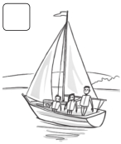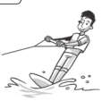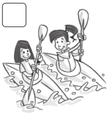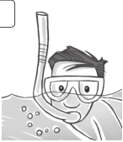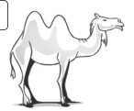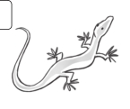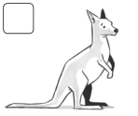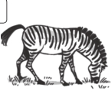

Test Summative test 2

1 Write and complete the puzzle.

1 2

1

c

a m

e

2

l

/5

3

camel 4

3 4

6

5

5 6

2 Complete the words. /3

1 g e t dr e ssed 2 ave brea fast

3 c tch the b s 4 w lk to sc ool

3 Check () the correct sentence. /3

1 2

He’s snorkeling.  He aren’t windsurfing.

He’re snorkeling. He isn’t windsurfing.

3 4

They’re kayaking. We’m sailing.

They’s kayaking.

Family and Friends Special Edition Grade 5 Assessment and Resource Portfolio Review 2

39
We’re sailing.

© Oxford University Press
Permission granted to reproduce for instructional use.

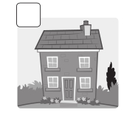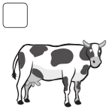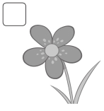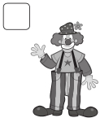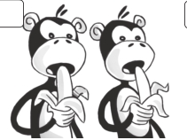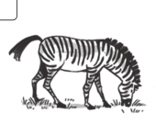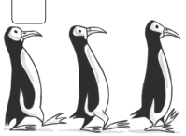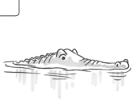

Summative test 2

4 Match.

/3

1 2 3 4

1 Are the monkeys eating? b a No, it isn’t.

2 Is the zebra running? b Yes, they are.

3 Is the crocodile swimming? c No, they aren’t.

4 Are the penguins sleeping? d Yes, it is.

5 Read and circle.

1 We has / have breakfast at eight o’clock.

2 My dad get / gets up at six o’clock.

3 He don’t / doesn’t catch the train to work.

4 Does she brushes / brush her teeth every morning?

5 I play / plays with my friends after school.

6 They don’t walks / walk to school.

7 What time does / do you start school?

8 Do / Does you have homework every day?

6 Write the words.
/7

/4

1 2 3 4 5

cow

7 Listen and complete.

1 t o y 2

20

l

/5

3 b 4 c n

5 s l 6 ster /30

Family and Friends Special Edition Grade 5 Assessment and Resource Portfolio Review 2
40
© Oxford University Press
Permission granted to reproduce for instructional use

