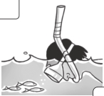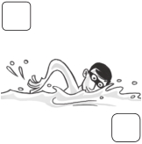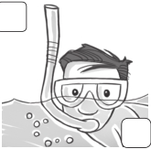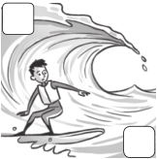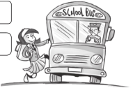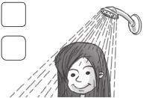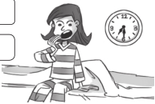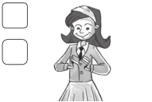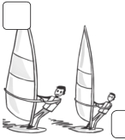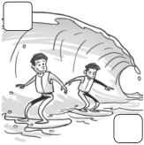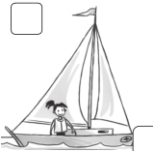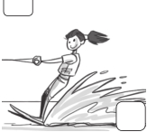

Test Skills test 2

Listening

1 Listen and check (). 21 /3

1 a b 2 a b



3 a b 4 a b

2 Listen and write.

22
crocodiles seven Animal Land penguins
giraffes three today monkeys Saturday
/5

1 Name of zoo: Animal Land 2 Opens:

3 Animals by the lake:

4 Number of camels:

5 At 3:00, watch

Reading a b

3 Read and order the pictures. Hi, my name’s Anna. I’m nine. Every day I get up at 7:30. First,
/5

I have a shower. Then I get dressed. Then I have breakfast in the kitchen. After breakfast
I brush my teeth. Next, I leave the house. I don’t walk to school. I always catch the bus. Finally,
I arrive at school just before 9:00.
c

e
d

f

1

Family and Friends Special Edition Grade 5 Assessment and Resource Portfolio Review 2
41
© Oxford University Press
Permission granted to reproduce for instructional use.

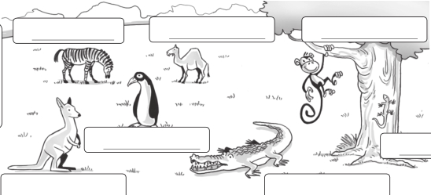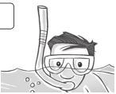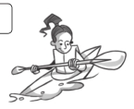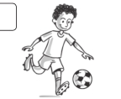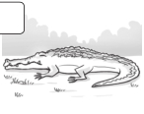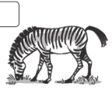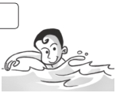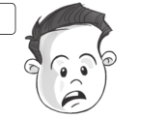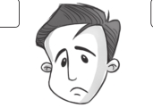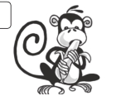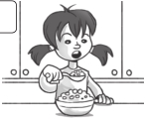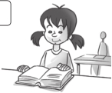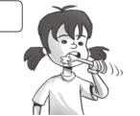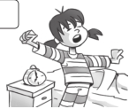

Skills test 2

Writing

4 Complete the words.

/8

1 wind s urf ing 2 kay ing 3 snork ing

4 swi ing 5 water k ing 6 sa ing

7 ur ing 8 poll ed 9 dang ous

5 Look and write. /6

monkey lizard
crocodile
zebra camel
kangaroo penguin
1 zebra
2
3

5 7

4 6

Speaking

6 Choose and describe the odd one out. /3

Picture b.
She’s at school. In the other pictures, she’s at home.
1

2

3

4
a

a

a

a
b

b

b

b
c

c

c

c
d

d

d

d

Family and Friends Special Edition Grade 5 Assessment and Resource Portfolio Review 2

42
/30

© Oxford University Press
Permission granted to reproduce for instructional use.

