Student’s name: ____________________
Class: 2/ ____
EXERCISES
- Look at the picture and choose the correct sentence a, b or c
A | B
- a. It’s sunny.  - It’s raining.  - It’s snowing. | 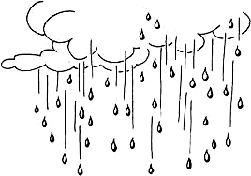
1. a. That’s my book.  b. That’s my blanket.  c. That’s my bear. | 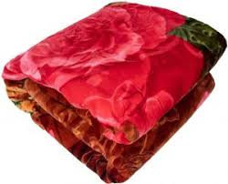
2. Play with me.  a. OK. Let’s swing.  b. OK. Let’s jump.  c. OK. Let’s run. | 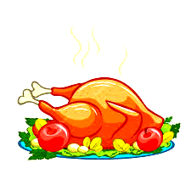  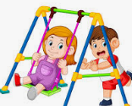
3. a. Have some pudding.
b. Have some soup.
c. Have some chicken.
4. a. She’s a teacher.  b. He’s a doctor.  c. She’s a farmer. | 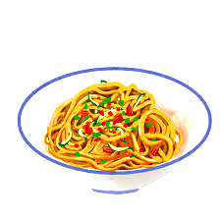  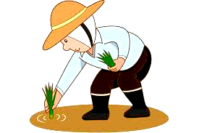
5. I’m hungry.
- I want noodles.
- I want soup.
- I want cookies.
- a. I’m wet.  - I’m cool.  - I’m cold. | 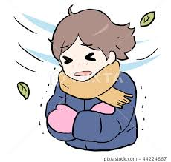
- a. OK. Let’s slide.  - OK. Let’s run.  - OK. Let’s swing. | 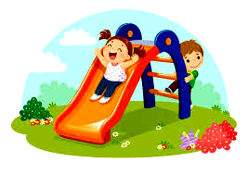
- a. Green light.  - Red light.  - Yellow light. | 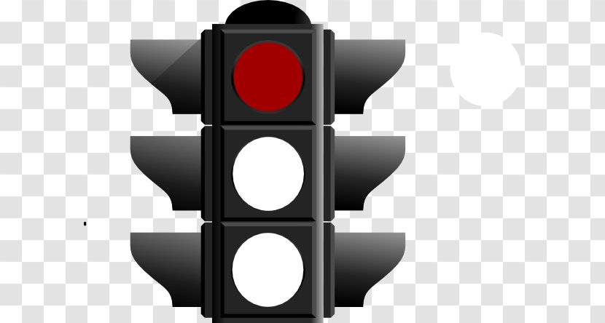

- Complete
today is I Play it That am slide pillow apples

- It is sunny.
- _____ is my blanket.
- No! It’s my _______.
- _________ with me.
- Have some _____________.
- ________ want chicken.
- No, Benny. Not ________.
- I ______ wet.
- OK. Let’s ________.
- Circle and write the words

soupchickenbearsnowingslidechipssunnynoodlesjump

 | 0. soup | 1._________________ | 2.__________________
3. ______________ |  | 4. _________________ | 5.__________________
6. ______________ |  | 7. _________________ | 8. __________________

- Unscramble
  - am / I / wet / . / I am wet.
  - teacher / She / is / a / . /
__________________________________________________

- my / It’s / No / bear / yellow / ! / . /
__________________________________________________

- chips / Have / some / . /
__________________________________________________

- windy / It / is / . /
__________________________________________________

- like / I / purple / .
__________________________________________________

- Go / light / Green / . / ! /
__________________________________________________

- run / Ok. / ’s / Let

_________________________________________________

- me / Play / with / .
________________________________________________
THE END
ANSWERS ( ĐÁP ÁN )
- Look at the picture and choose the correct sentence a, b or c
A | B
0.. a. It’s sunny.
- It’s raining.
  - It’s snowing.
1. a. That’s my book.
b. That’s my blanket.
c. That’s my bear.
2. Play with me.
a. OK. Let’s swing.
b. OK. Let’s jump.
c. OK. Let’s run.
3. a. Have some pudding.
b. Have some soup.
c. Have some chicken.
4. a. She’s a teacher.
b. He’s a doctor.
c. She’s a farmer.
5. I’m hungry.
  - I want noodles.
b. I want soup.
- I want cookies.
- a. I’m wet.
- I’m cool.
- I’m cold.
- a. OK. Let’s slide.
- OK. Let’s run.
- OK. Let’s swing.
- a. Green light.
- Red light.
- Yellow light.

II. Complete
today is I Play it That am slide pillow apples

- It is sunny.
- That is my blanket.
- No! It’s my pillow
- Play with me.
- Have some apples.
- I want chicken.
- No, Benny. Not today.
- I am wet.
- OK. Let’s slide .
- Circle and write the words
soupchickenbearsnowingslidechipssunnynoodlesjump
 | 0. soup | 1. chicken | 2. bear
3. snowing |  | 4. slide | 5. chips
6. sunny |  | 7. noodles | 8. jump

- Unscramble
- am / I / wet / . /
I am wet.
  - teacher / She / is / a / . She is a teacher.
  - my / It’s / No / bear / yellow / ! / . No! It’s my yellow bear.
  - chips / Have / some / . /

Have some chips.
  - windy / It / is / . /
It is windy.

  - like / I / purple / . / I like purple.

  - Go / light / Green / . / ! / Green light. Go !
  - run / Ok. / ’s / Let
Ok. Let’s run.

  - me / Play / with / .
Play with me.

