Phu Hoa 2 primary school. **REVIEW (Ôn tập)**

Class: 2/ ___ **UNIT 1 : WEATHER**

Full name: ____________________ ( Bài 1: Thời tiết )

1. ***Look and write*** *( Nhìn tranh và viết từ )*

sunny **raining** windy snowing hot cold wet cool



1. ***_raining___ 1.______________ 2. ______________ 3.______________***

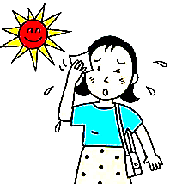

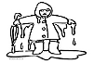

***4.____________ 5.*** *____________* **6.** _________________ 7. __________________

It’s……………… . / I’m ……............. .

1. ***Write the sentences (*** *Viết câu)*

[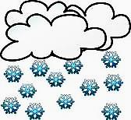](http://www.google.com.vn/imgres?start=164&biw=1280&bih=603&tbm=isch&tbnid=j-Iigg6OXnL8nM:&imgrefurl=http://www.clker.com/clipart-snowing.html&docid=EtYwJ6nf4KdqiM&imgurl=http://www.clker.com/cliparts/7/P/f/u/5/e/snowing-md.png&w=298&h=273&ei=gDsjUrWGKMPgkAXxroHAAw&zoom=1&iact=rc&dur=78&page=8&tbnh=144&tbnw=157&ndsp=24&ved=1t:429,r:87,s:100,i:265&tx=70&ty=73)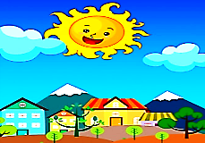

1. **It’s sunny**. 1. __________________ .

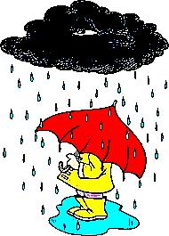

2. ____________ 3. ___________________



4. ______________ 5. ___________________

1. ***Reoder the words into the completed sentences (*** Sắp xếp từ thành câu hoàn chỉnh )
2. up ! / Hurry - **Hurry up**!
3. is / snowing / It / . - _________________________________
4. It / windy / ’s / . - _________________________________
5. cool / ’m / I / . - _________________________________
6. name / ’s / Long. / My - _________________________________
7. am / hot / I / . - _________________________________

**THE END**

**School year : 2019-2020**

**REVIEW ( UNIT 1 : WEATHER)**

**ANSWER ( Đáp Án )**

1. ***Look and write*** *( Nhìn tranh và viết từ )*

0. raining 1. windy 2. sunny 3. snowing

4. cold 5. hot 6. wet 7. cool

1. ***Write the sentences (*** *Viết câu)*
2. It’s sunny. 1. It’s snowing.

2. I’m hot. 3. It’s raining.

4. I’m wet. 5. I’m cold.

1. ***Reoder the words into the completed sentences (*** Sắp xếp từ thành câu hoàn chỉnh)
2. Hurry up !
3. It is snowing.
4. It’s windy.
5. I’m cool.
6. My name’s Long.
7. I am hot.

THE END