**REVIEW**

**GRDAE 2 : TINY TALK 1B**

**UNITS 1-2-3**

**Full name: ______________Class: 2/__**

**EX1: . Look, read and write into the sentence:( Nhìn, đọc và viết thành câu)**

|  |  |
| --- | --- |
| http://cdn.sheknows.com/printables/print/freddy_the_teddy.gif | ***Sue***: That’s my bear.  ***Benny*** : No, It’s my bear. |
| https://lh5.googleusercontent.com/-CgDuAOFqEAQ/TW3QUYh6oUI/AAAAAAAAHnk/dQl_RbCGzCM/s800/couette.gif | Sue: _________________  Benny: _______________ |
| http://www.do2learn.com/picturecards/images/imageschedule/pillow_l.gif | Sue: _________________  Benny: _______________ |
| http://www.polyvore.com/cgi/img-thing?.out=jpg&size=l&tid=12682844 | Sue: _________________  Benny: _______________ |

**EX 2:Look and write the words (nhìn và viết lại)**

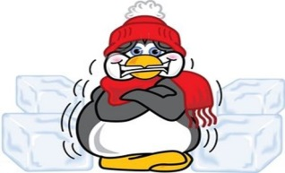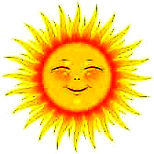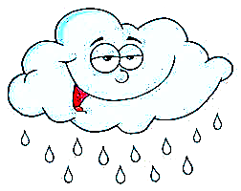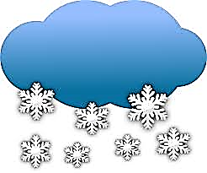

|  |  |  |  |  |
| --- | --- | --- | --- | --- |
|  |  |  |  |  |
| Kết quả hình ảnh cho hình minh họa mưa ướt**sunny** | Kết quả hình ảnh cho hình minh họa hot _________ | http://s.twistynoodle.com/img/r/bowl-of-noodles/n-is-for-noodles-4/n-is-for-noodles-4_worksheet.png?ctok=20120731225600__________ | Kết quả hình ảnh cho hình minh thịt gà__________ | http://azcoloring.com/coloring/rcj/KxA/rcjKxAXcR.jpg_________ |
|  |  |  |  |  |
| _________ | _________ | _________ | ___________ | __________ |
|  |  |  |  | Kết quả hình ảnh cho be quiet |
| https://lh5.googleusercontent.com/-CgDuAOFqEAQ/TW3QUYh6oUI/AAAAAAAAHnk/dQl_RbCGzCM/s800/couette.gif | http://www.do2learn.com/picturecards/images/imageschedule/pillow_l.gif | http://cdn.sheknows.com/printables/print/freddy_the_teddy.gif | http://www.polyvore.com/cgi/img-thing?.out=jpg&size=l&tid=12682844 |  |
| ___________ | __________ | _________ | **__________** | **Be quiet !_** |

**EX 3: Choose the best word: (chọn từ đúng)**

|  |
| --- |
| **Pillow Be quiet! Bear blanket bed** |

|  |  |  |  |  |
| --- | --- | --- | --- | --- |
| http://cdn.sheknows.com/printables/print/freddy_the_teddy.gif  1**. bear** | Kết quả hình ảnh cho hình minh họa cái chăn  2. ------------------ | http://www.polyvore.com/cgi/img-thing?.out=jpg&size=l&tid=12682844  3. ------------------ | http://www.do2learn.com/picturecards/images/imageschedule/pillow_l.gif  4. ------------------ | Kết quả hình ảnh cho be quiet  5. ------------------ |

**EX 4 : Choose the best answers: (Chọn đáp án đúng)**

|  |  |  |
| --- | --- | --- |
| Kết quả hình ảnh cho hình minh họa cái chăn  1. It’s my _____  a. blanket  b. bed  c. Be quiet! | http://health.syr.edu/_images/_blog/heat  2. I’m ________  a. hot.  b. wet.  c. sunny. | Kết quả hình ảnh cho hình minh họa thit gà  3. Have some _____  a. hungry  b. soup  c. chicken |
| Kết quả hình ảnh cho be quiet  4. Be _____  a. quiet!  b. cold  c. blanket | 5. It’s _________http://www.cliparthut.com/clip-arts/502/its-windy-502190.gif  a. cold.  b. windy.  c. hungry. | http://cdn.sheknows.com/printables/print/freddy_the_teddy.gif  6. It’s my _____  a. noodles  b. bear  c. pillow |
| Kết quả hình ảnh cho hình minh họa mây  7. _____ cloudy.  a. I’m  b. It’s  c. cloudy | 8. Have some_____ http://s.twistynoodle.com/img/r/bowl-of-noodles/n-is-for-noodles-4/n-is-for-noodles-4_worksheet.png?ctok=20120731225600  a. noodles  b. cold  c. chicken | http://www.danaroc.com/blog/wp-content/themes/danaroc/uploads/Rainy_Weather_1.jpg  9. I’m _______  a. raining.  b. snowing.  c. wet. |
| http://www.iamstarving.net/images/hungry_guy.png  10. I’m_______  a. cold  b. hungry  c. wet | Kết quả hình ảnh cho hình minh họa tuyêt  11. It’s _________  a. chicken.  b. cloudy.  c. snowing. | Kết quả hình ảnh cho hình minh họa bed  12. It’s ____ bed.  a. I’m  b. bear  c. my |
| http://1.bp.blogspot.com/-ZoYKFqwyMv4/TxbteqIWdVI/AAAAAAAACB0/1smJEyDBri0/s1600/0093-0910-1409-2711_cartoon_freezing_cold_penguin_shivering1.jpg  13. _____ cold.  a. I’m  b. It’s  c. Be quiet ! | http://www.do2learn.com/picturecards/images/imageschedule/pillow_l.gif  14. It’s my _____  a. bed  b. bear  c. pillow | Screen Clipping  15. It’s _________  a. sunny.  b. wet.  c. raining. |

THE END