Name: _________________ EXERCISES Class: 2/ ____
Subject: English
I/ Match ( Nối )

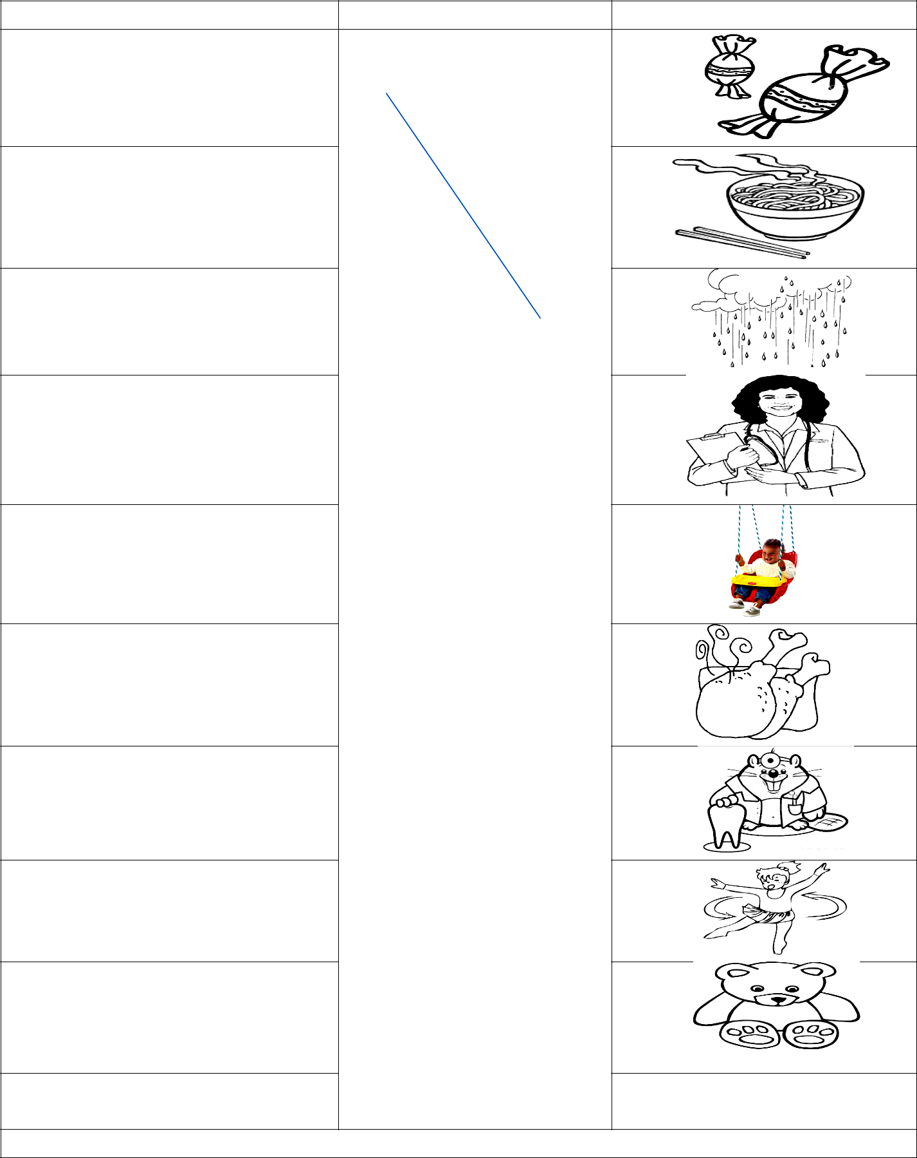 |  | A |  |  |  |  |  |  | B
0. | It’s raining. |  |  |  | * |  | *
 |  |  |  |  |  |  |  | a.
1.That’s my bear. |  |  |  |  | * |  | *
 |  |  |  |  |  |  |  | b.
2.Play with me. |  |  |  |  | * |  | *
Ok. Let’s turn around. |  |  |  |  | * |  | *
 |  |  |  |  |  |  |  | c.
3.Have some chicken. |  |  |  |  | * |  | *
 |  |  |  |  |  |  |  | d.
4.He’s a doctor. |  |  |  |  | * |  | *
 |  |  |  |  |  |  |  | e.
5. | I’m hungry. I want noodles. |  |  |  | * |  | *
 |  |  |  |  |  |  |  | f.
6. | I want candy. |  |  |  | * |  | *
 |  |  |  |  |  |  |  | g.
7. | She’s a doctor. |  |  |  | * |  | *
 |  |  |  |  |  |  |  | h.
8. | Ok. Let’s swing. |  |  |  | * |  | *
 |  |  |  |  |  |  |  | i.
9. | He’s a dentist. |  |  |  |  |  |  | k. | 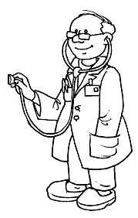
0 – c |  | 1- | 2- | 3- | 4- | 5- | 6- | 7 - | 8- | 9-

II/ Complete

Not is want with it is am run my Have

- It is snowing.
- That _____ my puppet.
- No! It’s _______ blanket.
- Play _________ me.
- _________ some cookies.
- I ________ ice cream.
- No, Benny. ________ today.
- I ______ wet.
- OK. Let’s ________.
III/ Unscramble
  - am / I / hungry / . / I am hungry.

- police officer / She / is / a / . /

____________________________________________________________

- my / That / is / pillow / pink / . /
____________________________________________________________

- chips / I / want / . /

___________________________________________________________

- No, / Not / John. / today. /

- play / OK / Let’s / . / . /
___________________________________________________________

- careful ! / light. / Be / Yellow /
__________________________________________________________

IV/ Circle and write the words

 | 0. hot | 1._________________ | 2.__________________
3. ______________ |  | 4. _________________ | 5.__________________

6. ______________ 7. _________________ 8. __________________
hotfarmerdoctor
chipsnoodlesblanketpillowbearcold

 |  |  |  |  |  | ANSWEĐ( Đáp Án )
I I/ Match
 |  | A |  |  |  |  |  |  |  | B
0. It’s raining. |  |  |  |  | * |  | *
 |  |  |  |  |  |  |  |  | a.
1.That’s my bear. |  |  |  |  | * |  | *
 |  |  |  |  |  |  |  |  | b.
2.Play with me. |  |  |  |  | * |  | *
 | Ok. Let’s turn around. |  |  |  | *
 |  |  |  |  |  |  |  |  | c.
3.Have some chicken. |  |  |  |  | * |  | *
 |  |  |  |  |  |  |  |  | d.
4.He’s a doctor. |  |  |  |  | * |  | *
 |  |  |  |  |  |  |  |  | e.
5. I’m hungry. I want noodles. |  |  |  |  | * |  | *
 |  |  |  |  |  |  |  |  | f.
6. I want candy. |  |  |  |  | * |  | *
 |  |  |  |  |  |  |  |  | g.
7. She’s a doctor. |  |  |  |  | * |  | *
 |  |  |  |  |  |  |  |  | h.
8. Ok. Let’s swing. |  |  |  |  | * |  | *
 |  |  |  |  |  |  |  |  | i.
 |  |  |  |  |  |  |  |  | x | 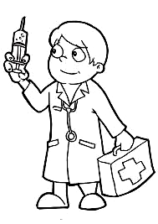
9. He’s a dentist. |  |  |  |  | * |  | *
0 – c |  | 1- i | 2- h | 3- f | 4- k |  | 5- b 6- a |  | 7 - d | 8- e | 9- g
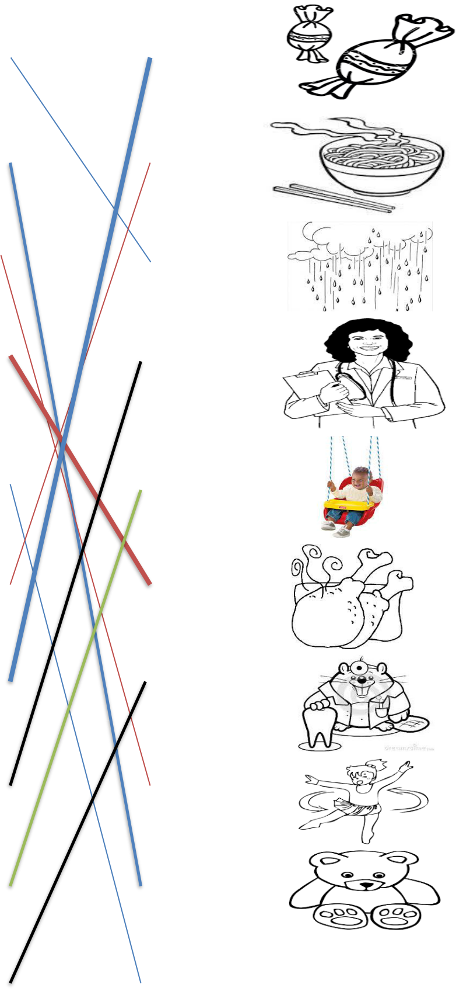
II/ Complete

Not is want with it is am run my Have

- It is snowing.
- That is my puppet.
- No! It’s my blanket.

- Play with me.
- Have some cookies.
- I want ice cream.
6. No, Benny. Not today.
  - I am wet.
  - OK. Let’s run.

III/ Unscramble

    - am / I / hungry / . / I am hungry.

- police officer / She / is / a / . / She is a police officer.

- my / That / is / pillow / . / That is my pillow.

- chips / I / want / . /

I want chips.

- No, / Not / John. / today. / No, John. Not today.

- play / OK / Let’s / . / . /
OK. Let’s play.

- careful ! / light. / Be / Yellow / Yellow light. Be careful !

IV/ Circle and write the words

 | 0.. | hot | 1.farmer | 2.docctor
3. chips |  |  | 4. noodles | 5.blanket
6. |  | pillow | 7. bear | 8. cold

