Full name: _____________________
Class: 2/ ____
EXERCISES
REVIEW (UNITS 1-7 )
0. reab bear | 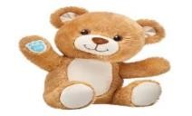 | - That’s my blabket.
1. anktebl  …………………… | 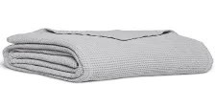 | ➢ No! It __________________
2. owillp  …………………… | 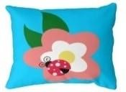 | ➢ No! It __________________
3. unnsy  …………………... |  | ➢ It ___________________
4. snwnigo  ……………….…. | 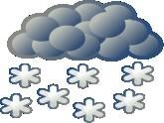 | ➢ It ______________________
5. ainrgnin  ………………..… |  | ➢ It ____________________
6. ecilop ffiecro  ………………..… |  | ➢ He _____________________
7. ramfer  ………………….. | 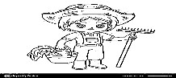 | ➢ She ___________________
8. otrdco  …………………... |  | ➢ She ___________________
9. oolesnd  ……………..……. | 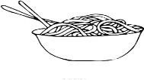 | ➢ Have ___________________
10. gryunh  …………….…….. | 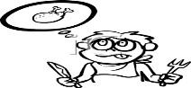 | ➢ I’m _____________________
11. ldsei  ………………….. | 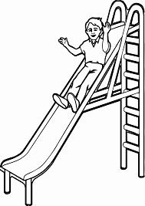 | ➢ Ok. ____________________
12. ngwsi  …………………. | 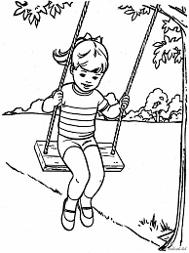 | ➢ Ok. ____________________

- Unscramble ( sắp xếp )
- up / raining / Hurry / It’s / . / . / ___________________________________
- chicken / I / want / . ___________________________________
- my / No! / It’s / pillow / . ___________________________________
- ice cream / I / want / . __________________________________
- Green / Go! / light. / __________________________________
- a / She / ’s / police officer / . __________________________________
- quite / Mmm! / Be / . / __________________________________
- Ok. / jump / ’s / Let / .
- That / ’s / blanket / my /.
- with / Play / me / . /
- a He / is / farmer / . / ___________________________________
- today. / Benny, / No / Not / ___________________________________
- cold / snowing / I’m / It’s / . / ___________________________________
- slide / Ok. / Let / ’s / . ___________________________________

REVIEW ( UNIT 7)

III. Find and circle the words: Tìm và khoanh tròn từ đúng.

0. family 1._____________ 2._____________ 3.___________
4. ___________ 5. ____________ 6.______________ 7.___________
8. ___________ 9._____________. 10. ____________ 11. __________

IV. Match (nối)
A B
1. | Mẹ |  |  | Brother
2. | Bố |  |  | Mommy
3. | Anh trai |  |  | Sister
4. | Em gái |  |  | Daddy
5. | Nhà |  |  | Family
6. | Gia đình |  |  | Home

V. Unscramble ( Sắp xếp)
- daddy / my / He / ’s / . ___________________________
- Daddy / home / ’s / . ____________________________
- ’m / home / I / . ____________________________
- home / Hey! / Daddy / ’s . ____________________________
- ’s / home / . / Mommy ____________________________
- home / Mommy / Hey! / ’s / . ____________________________
- home / At / . ____________________________
- ’s / home / He / . ____________________________
- My / ’s / a / farmer / daddy / . ____________________________
- My / doctor / a / ’s / mommy / . _____________________________

THE END

