Exercise 1 Look and write

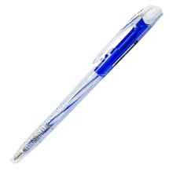 | 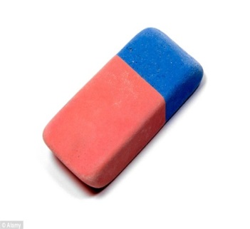 | 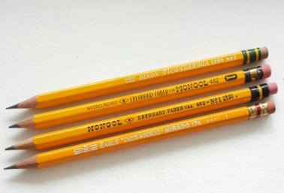 | 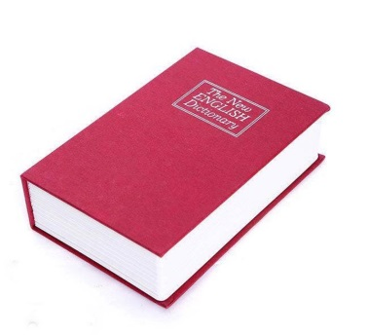
Exercise 2 Answer the question :

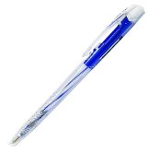 | a) What’s this ?  It’s a…………………….
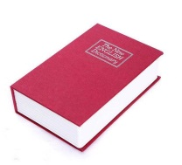 | b) What’s this ?  ……..............a book
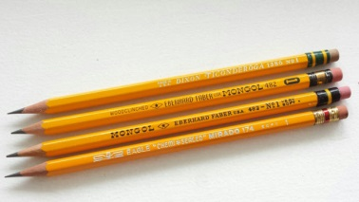 | c) What’s this ?  ……..............................
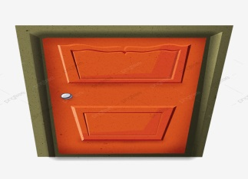 | d) What’s this ?  ……..............................
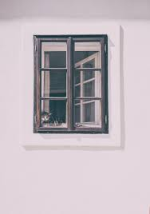 | e) What’s this ?  ……..............................
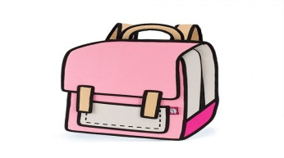 | f ) What’s this ?  ……..............................

Exercise 3 Look and complete the sentence.
 | This is……………………..
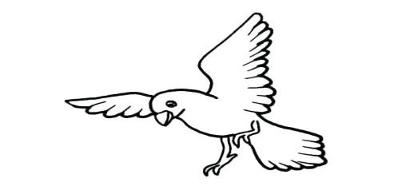 | This is……………………..
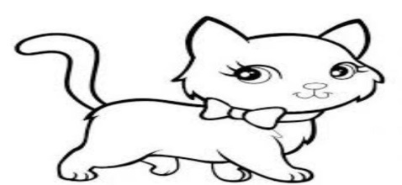 | This is……………………..
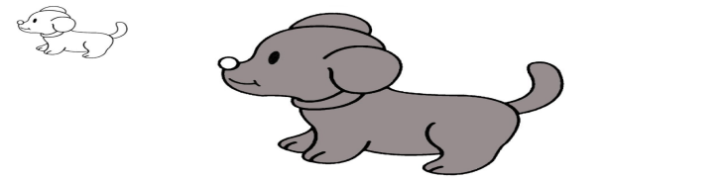 | This is……………………..

Exercise 4 Order the words
- Book / it’s /a
………………………………………………..
- Is / an / this /eraser
………………………………………………..
- Pencli / it’s / a
………………………………………………..
- This / what / ‘s / ?
………………………………………………..
- Are / how / old / you / ?
………………………………………………………..
Exercise 5 : Read and color
ORANGE
PINK

PURPLE
YELLOW
GREEN
BLUE

BLACK
RED

Exercise 7 : Write the numbers :
10 : …………………………… 2 : ………………………………..
5 : …………………………….. 4 : …………………………………
9 : …………………………….. 7 : …………………………………
8 : …………………………… 1 : ………………………………..
6 : …………………………….. 3 : …………………………………

