

**TOEFL**

**Primary**

2

Reading

# Look at the picture. Circle A, B, or C.

|  |  |  |
| --- | --- | --- |
| Example | (A)  (B)  (C) | A teddy bear A doll  A kite |
| 1 | (A)  (B)  (C) | This is my train. This is my bike. This is my car. |
| 2 | (A)  (B)  (C) | This is your bike. This is my bike.  This is my teddy bear. |

* 1. 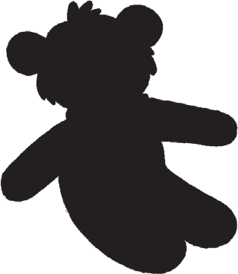Is it a kite?

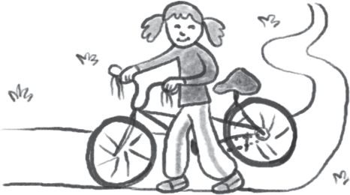

* + 1. No, it isn’t. It’s a teddy bear.
    2. Yes, it is. It’s a kite.
    3. No, it isn’t. It’s a ball.
  1. Is this your teddy bear?

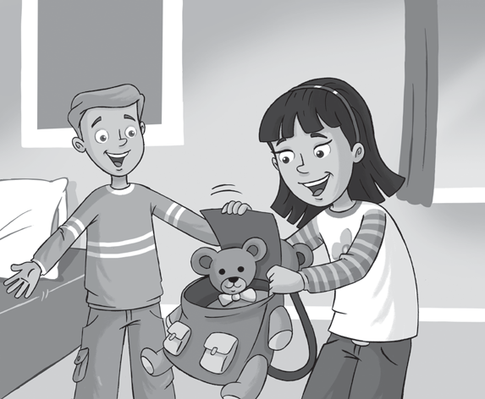

*Is this your teddy bear?*

* + 1. No. It’s my bag.
    2. No, it isn’t.
    3. Yes, it is.

**TOEFL**

**Primary**

**Reading**

# Read and guess. What is it? Circle A, B, or C.

It’s a toy. It’s long and red. What is it?

Example

(A)

It’s a train.

1. It’s a dog.
2. It’s a bike.
3. It’s an animal. It’s big. It’s black and white. What is it?
   1. It’s an egg.
   2. It’s a zebra.
   3. It’s a ruler.
4. It’s my favorite color. My cat is this color. What is it?
   1. Blue
   2. Animal
   3. White
5. It’s my favorite toy. It’s small and brown. What is it?
   1. It’s your teddy bear.
   2. It’s your pencil.
   3. It’s your fig.

**TOEFL**

**Primary**

**Reading**

# 3 Read and answer the questions. Circle A, B, or C.

Hello! My name is Kim. This is my favorite toy. It’s a car. It is black and red. I love my car! This is my favorite animal. It’s my black cat, Jake. My favorite color is black!

What is the girl’s name?

Example

1. Toy Kim

(B)

(C) Jake

1. What is Kim’s favorite toy?
   1. A car
   2. A cat
   3. An animal
2. What color is Kim’s favorite animal?
   1. Black
   2. A cat
   3. Black and red
3. What is Jake?
   1. A toy
   2. A color
   3. A cat

# Match and write.

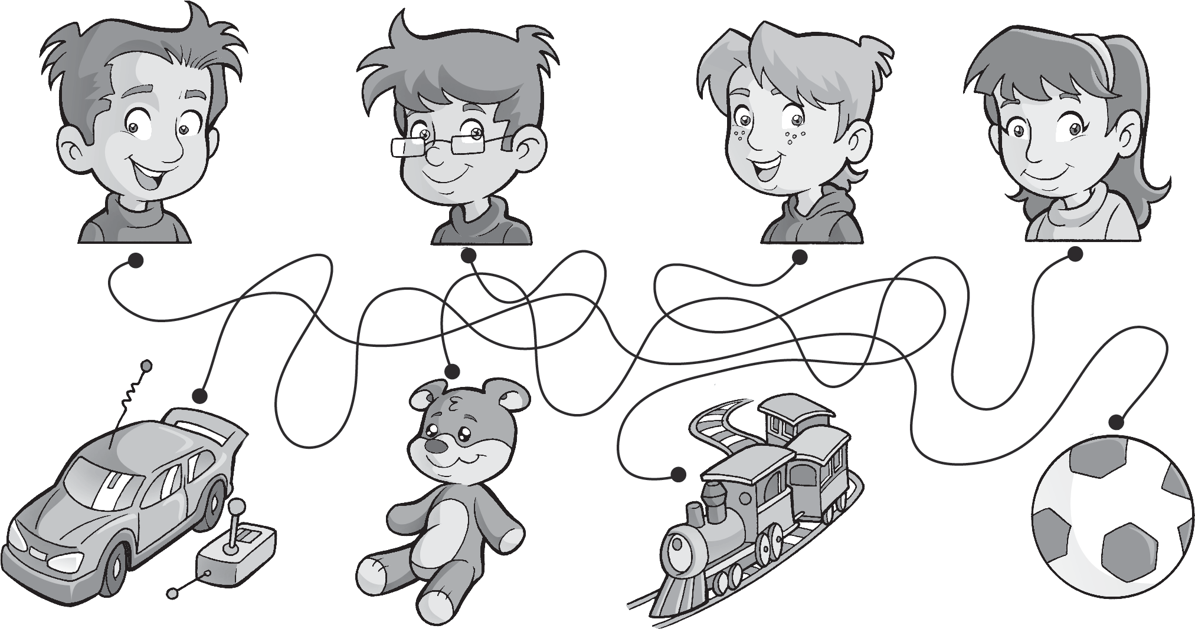

**1**

**2**

**3**

**4**

1 This is my ball .

3 This is my .

2 This is my .

4 This is my .



**Worksheet**

2

Extra writing

# Look and write.

Yes, it is. No, it isn’t.

* 1. Is this your 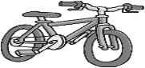  *bike* ? Yes, it is.



* 1. Is this your 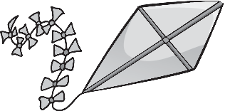 ?



* 1. Is this your 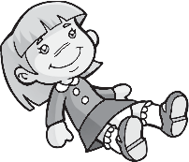 ?



* 1. Is this your 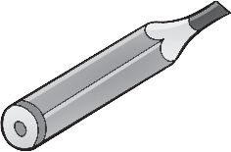 ?



* 1. Is this your ?



**Worksheet**

2

Values

Be kind to people

1 **Look and draw.**

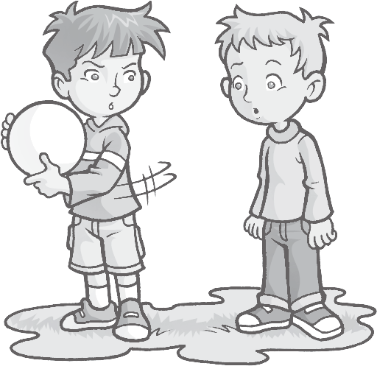

**1**

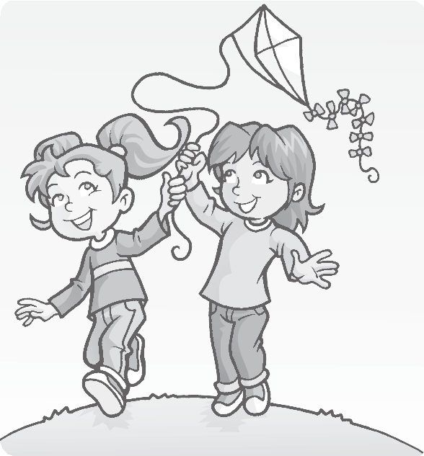

**2**

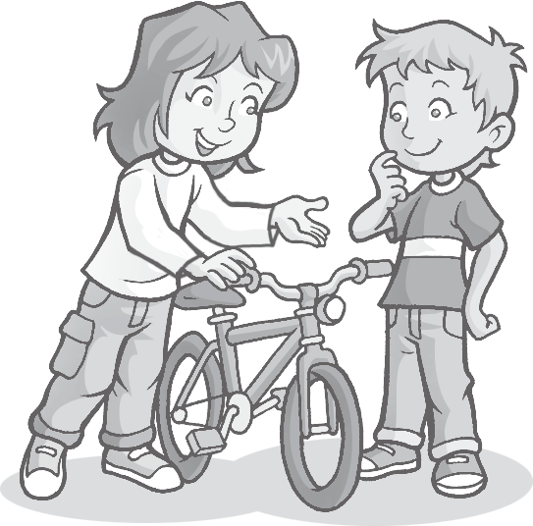

**3**

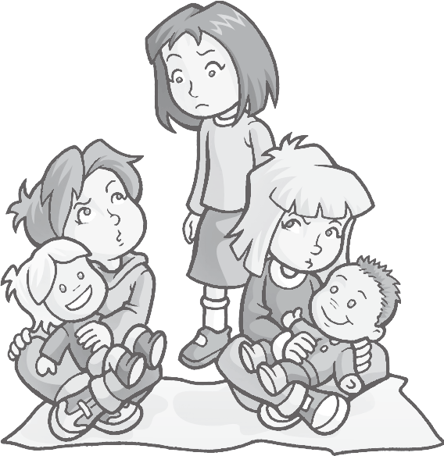

**4**

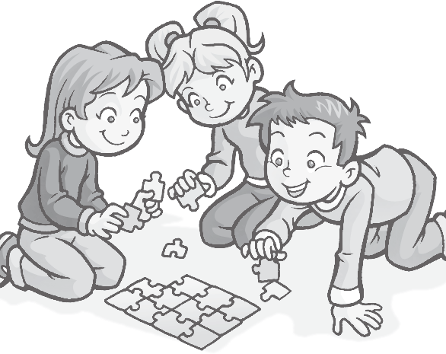

**5**

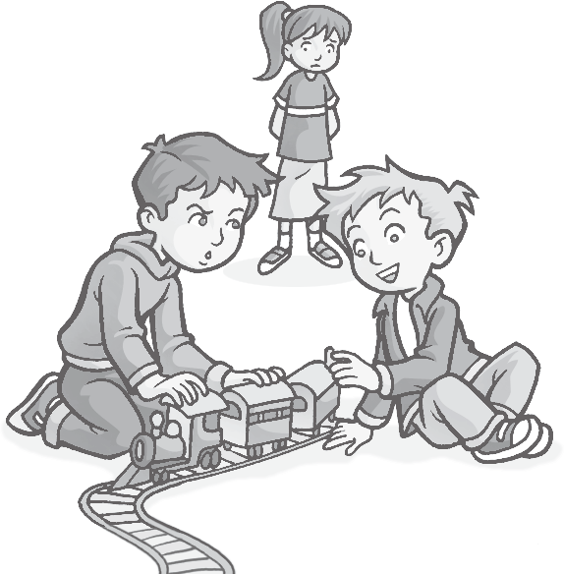

**6**

# 2 Choose a toy for your friend. Draw and color.

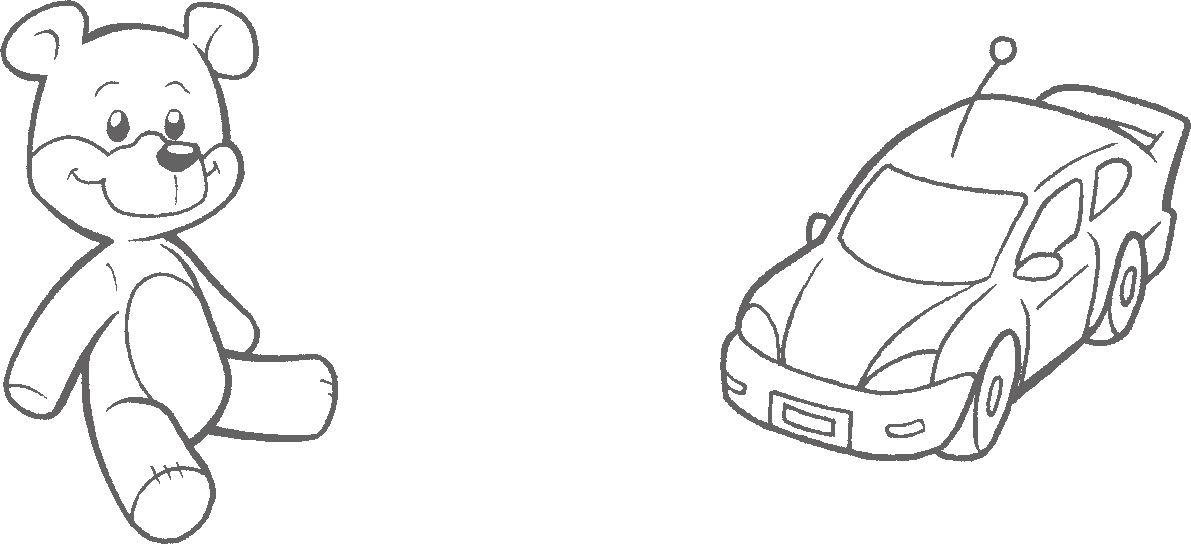

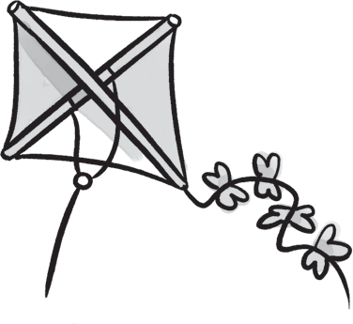 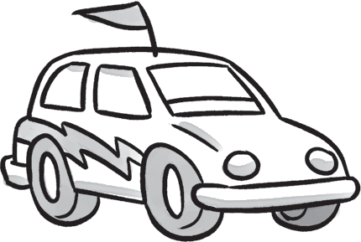

1. 2 bike / kite 3 car / hat 4 doll / ball

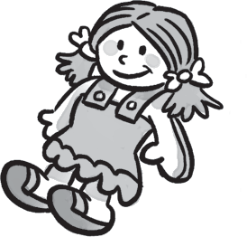

doll / train

# Write and match.

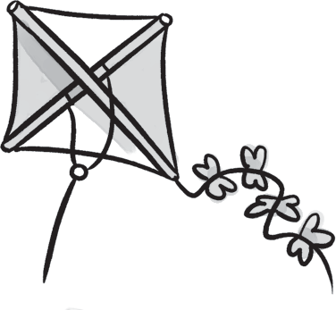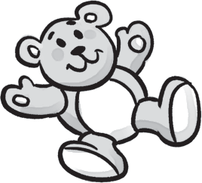

**/ 4**

* 1. i k e t *kite*
  2. 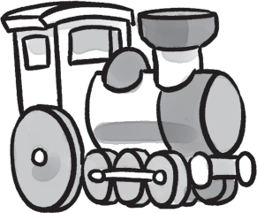o l d l
  3. 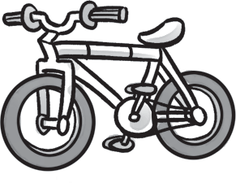n t r i a 4 d t e d y r a e b 5 i k e b

# Order the words.

1

This

bike.

is

my

2

it

Yes,

is.

3

my

This

kite.

is

4

your

Is

this

train?

5

isn’t.

it

No,

6

this

your

bag?

Is

# Complete the answers.

*This is my bike.*

**/ 5**

**/ 3**

1. Is this your teddy bear? Yes, it is .



**Test**

2

Unit test

1 **Circle the correct word.**

**/ 3**

1. Is this your doll? No, it .
2. Is this your hat? No, .

*/15*

1. Is this your train? Yes, .