

**Worksheet**

7

Extra writing

# Write the words.

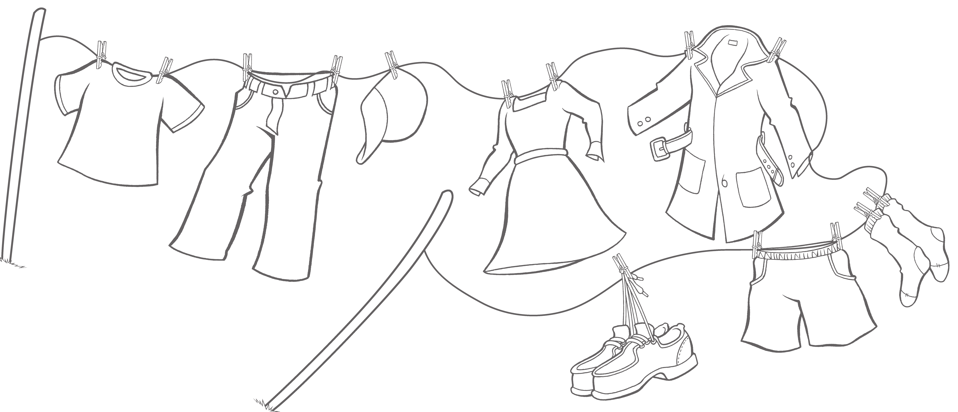

i

s h t r

p

s

h

a

t

**3**

a o

**5**

t

**1**

-

T

c

n

a

t

e

d

s

s

r

**2**

**4**

c s k

o

r t

s h

s

**8** s e s ho

o

s

**7**

**6**

1 *T-shirt* 2 3

4 5 6

7 8

# Look at the white clothes. Write. Then color.



**1**



**2**

* 1. *His pants* are blue.
  2. is pink.
  3. 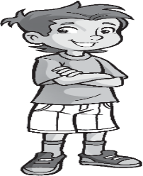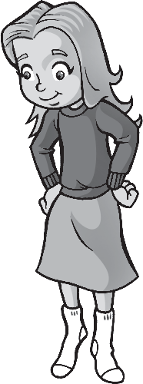 are red.



**3**



**4**

* 1. are yellow.



**Worksheet**

7

Values

Warm clothes and cool clothes

# Draw.

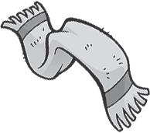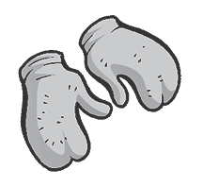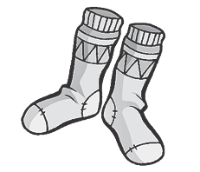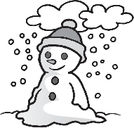

1. 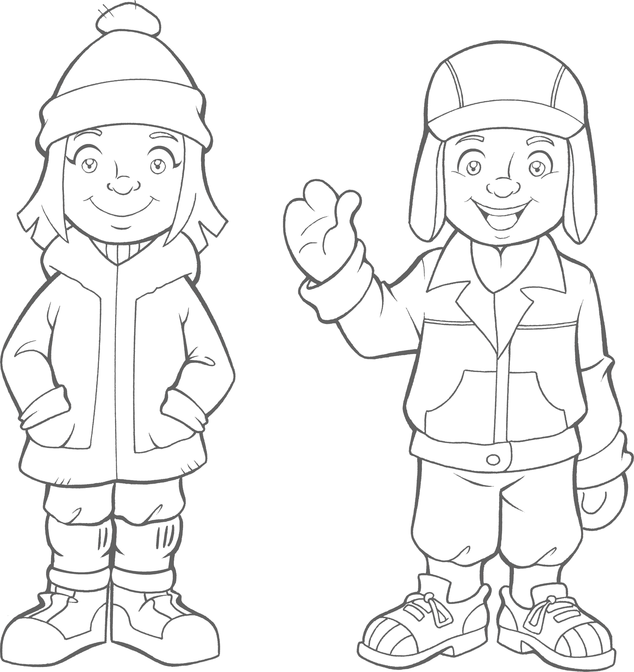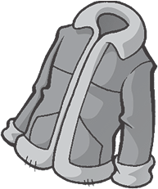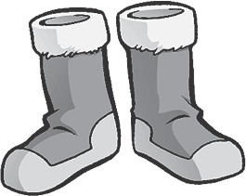**Read and color.**

Her coat is red.

His pants are blue. Her hat is pink.

Her pants are yellow. His socks are green.

His hat is orange. Her socks are pink.



**Test**

7

Unit test

# Complete the words.

**/ 4**

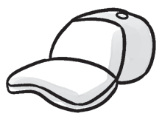

**1**

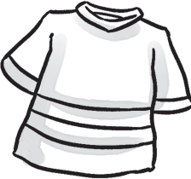

**2**

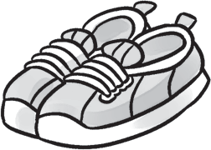

**3**



**4**

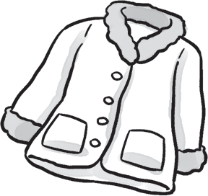

**5**

h a t T- s i t s o s p ts c t

# Circle the odd-one-out. Write.

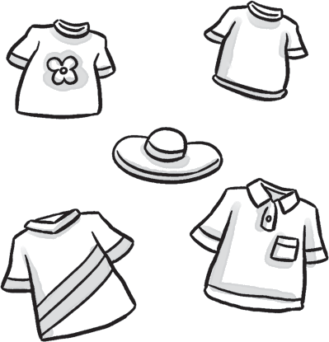

**1**

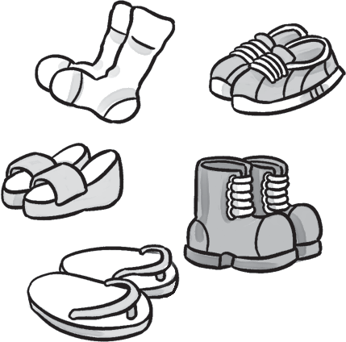

**2**

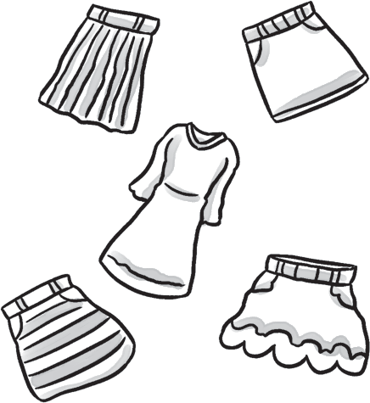

**3**

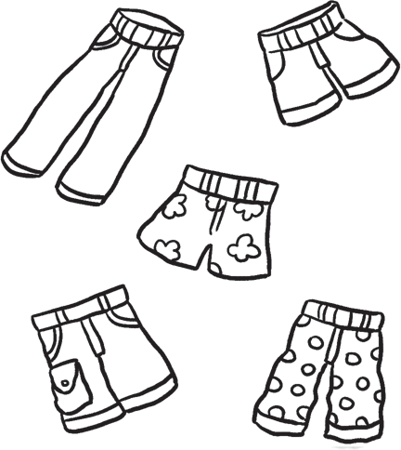

**4**

**/ 3**

hat

# Complete the sentences with *his* or *her*.

**/ 3**

1 These are her shoes. 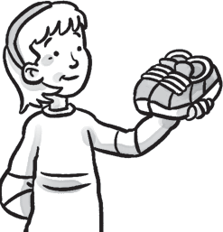 2 This is hat. 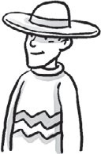

3 This is coat. 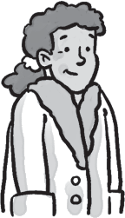 4 These are shorts. 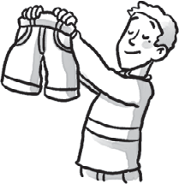

# Order the words.

**/ 5**

1 *Are these his shoes?*

these

Are

his

shoes?

2

they

Yes,

are.

3

her

Are

socks?

these

4

this

Is

hat?

her

5

aren’t.

No,

they

6

coat?

Is

this

his

*/15*