Exercise 1 Look and write

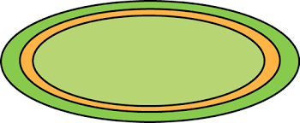 | 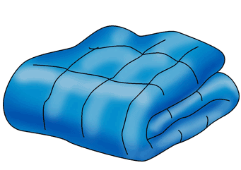 | 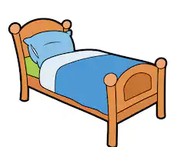
Exercise 2 Circle the correct answer.

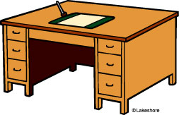 | a) How many desks are there?  There is/ There are one desk.
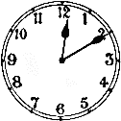 | b) How many clocks are there?  There is/ There are two clocks.
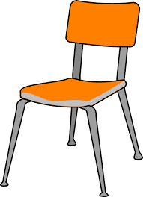 | c) How many chairs are there?  There is/ There are three chairs.
 | d) How many cabinets are there?  There is/ There are one cabinet.
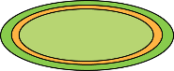 | e) How many rugs are there?  There is/ There are three rugs.
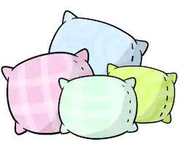 | f ) How many pillows are there?  There is/ There are four pillows.

Exercise 3 Read and complete the sentence.

1. How many chairs………………………………?
……………………………….a chair.
2. How many rugs……………………………….?
……………………………….three rugs.
3. How many bags……………………………….?
……………………………….eleven bags
4. How many pillows ……………………………?
……………………………….six pillows.
5. How many lamps …………………………….?
……………………………….two lamps.
6. How many beds……………………………….?
……………………………….three beds.
Exercise 4 Make questions for these answer
a) There is a bed in the bedroom.
How many beds are there in the bedroom ?
b) There are two pillows on the bed.
………………………………………………………………………………………..
c) There is a lamp on the cabinet.
………………………………………………………………………………………..
d) There are four books in the bag.
………………………………………………………………………………………..
e) There is a cabinet in the living room.
………………………………………………………………………………………..

Exercise 5 : Look at the picture and read the text .Are there sentences true
( ) or false ()
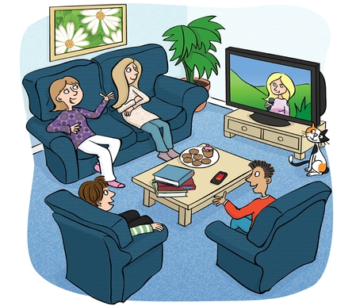 | - There is a TV on the TV stand .  - There are three people in the room.  - There is a cat next to the TV stand .  - There are two chairs in the room.  - There are two tables in the room.  - There is a sofa in the room.  - There is a picture on the wall.  - There are three books on the table.  - There is an orange on the table.

Exercise 7 Put the words in the correct order
a) There – a bed – is – in – the bedroom.
………………………………………………………………………………………….
b) two – the bed – There are – pillows – on
………………………………………………………………………………………….
c) a blue rug – There – is – the floor – on
………………………………………………………………………………………….
d) are – There – ten books – the shelf – on
………………………………………………………………………………………….
e) There – in – the kitchen – are – five chairs
………………………………………………………………………………………….
f) How many – pictures – on the wall - are – there ?
………………………………………………………………………………………….

