Phu Hoa 2 primary school. **REVIEW (Ôn tập)**

Class: 5/ ___ **UNIT 1 : THEY’RE FROM AUSTRALIA.**

Full name: ____________________

1. ***Write the name of the country*** *( Viết tên nước* )

( Viet Nam / Mexico / Australia / Korea / the U.S.A / Brazil / **England** / Thai land )

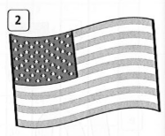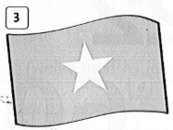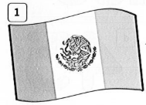

0

**England**   **_____________**   **___ __________**

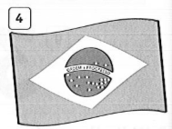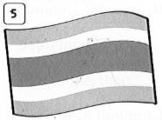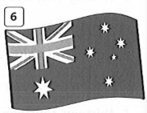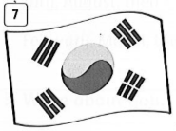

**___________ __________ _______________ ____________**

1. ***Fill a correct word in the blank*** ( *Điền 1 từ đúng vào chỗ trống* )

( ***Where*** / from / are / Is / you / he / He’s / They / ***the U.S.A*** / We’re / I am / isn’t )

1. **Where** is Mrs Young from? - She’s from **the U.S.A.**
2. Where’s ______ from? - He’s _________ Korea.
3. Where ______ Amy and Max from? - _______ ’re from Australia.
4. Minh and I are Vietnamese. ___________ from Viet Nam.
5. Are ______ from Mexico? – Yes, ___ _____ .
6. **____** he Billy ? - No, he ______. _______ Jack.
7. ***Put the words in right order*** *(Đặt từ vào vị trí đúng)*
8. Brazil / am / from / I / . ***_____I am from Brazil ._______***
9. is / from / Where / she / ? ___________________________________________?
10. birthday ? / is / Nga’s / When / __________________________________________?
11. Her / in / September. / birthday / ’s / _____________________________________.
12. are / How many / in / Viet Nam / seasons / there / ?

______________________________________________________________________

1. ***Answer the question****( Trả lời câu hỏi)*
2. What’s your name ? - ________________________________________________
3. How old are you? - ________________________________________________
4. What’s your favorite season? - __________________________________________
5. Where are you from? - ________________________________________________
6. Are you from Binh Dương or Ha Noi? -____________________________________
7. Do you like summer ? -________________________________________________
8. Is the weather hot in winter ? - __________________________________________
9. ***Complete the words*** *( Hoàn thành từ )*

**( br sn sp dr br cr )**

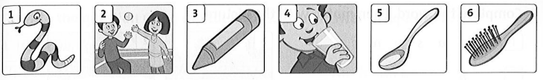

***__ake __ ay __ ayon __ ink __oon ___ ush***

***The End***

***REVIEW SCHOOL YEAR : 2019-2020***

***ANSWER ( Đáp Án)***

***Unit 1: They’re from Australia.***

1. ***Write the name of the country*** *( Viết tên nước* )
2. England 1. Mexico 2. The U.S.A 3. Viet Nam 4. Brazil 5. Thai land

6. Australia 7. Korea

1. ***Fill a correct word in the blank*** ( *Điền 1 từ đúng vào chỗ trống* )
2. Where - the U.S.A.
3. he - from
4. *are - They*
5. *We’re*
6. *you - I am*
7. Is - isn’t. - He’s
8. ***Put the words in right order*** *(Đặt từ vào vị trí đúng)*
9. - *I am from Brazil .*
10. - *Where is she from?*
11. - When is Nga’s birthday ?
12. - Her birthday’s in September.
13. - How many seasons are there in Viet Nam ?
14. ***Answer the questions*** *( Trả lời câu hỏi)( Chữ in đậm các em có thể thay từ khác)*
15. - My name is (’s)_**Lan.**
16. - I’m **eleven** years old ./ I’m **11**.
17. - My favorite season is **spring**. / I like **spring**.
18. - I’m from **Ha noi**. / **Viet Nam.**
19. - I’m from **Binh Dương*.***
20. - Yes, I do. / No, I don’t.
21. – No, it isn’t. It’s **cold**.
22. ***Complete the words*** *( Hoàn thành từ )*

***Sn****ake*  ***pl*** *ay*  ***_cr a****yon* ***_dr*** *in****k _sp****oon* ***_br*** *ush*

***The End***