**TOEFL**

**Primary**

4

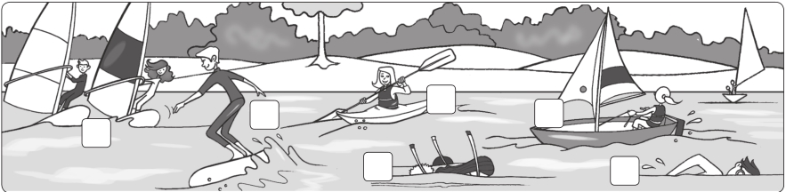

4

**Worksheet** Extra writing

1 **Unscramble and write.**

**1** I love our apartment. **2** We don’t go to that beach.

It’s beautiful (ueablifut). It’s (lolutdep).

**3** This is my favorite beach. **4** Look, that park doesn’t have any flowers.

It’s big and

**5** That playground is

(lenac).

It’s

(guyl).

(erandougs).

We don’t play there.

2 **Look and correct the sentences.**

**1** **2** **4** **5**

**3** **6**

**1** They’re kayaking. They aren’t kayaking. They’re windsurfing.

**2** He’s swimming.

**3** They’re sailing.

**4** She’s snorkeling.

**5** She’s waterskiing.

**6** He’s surfing.

**What’s your favorite sport?**

Write a sentence and draw yourself.

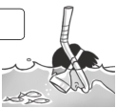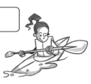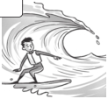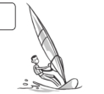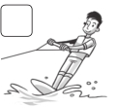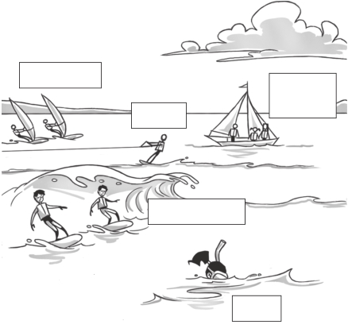

**Test** 4 Unit test

1 **Complete the words.**

**1** cl e an **2** po luted

2 **Write and match.**

**3** u ly

**4** be utiful

**5** dan erous

**/4**

**/5**

**1** frus surf c **a** **c**

**2** dinwurfs

**3** ilsa

**4** roksnel

**5** yakka

**6** skawtrei

**d**

**b**

**e**

**f**

3 **Complete the sentences.**

is are isn’t aren’t

**/6**

**1** Ella is snorkeling.

**2** Ed and Tim

**3** The Lee family

windsurfing.

kayaking.

Ed & Tim

Chris

the Lee family

**4** Chris waterskiing.

**5** Rob and Tom

**6** The Lee family

**7** Ella

surfing.

snorkeling.

sailing.

Rob & Tom

Ella