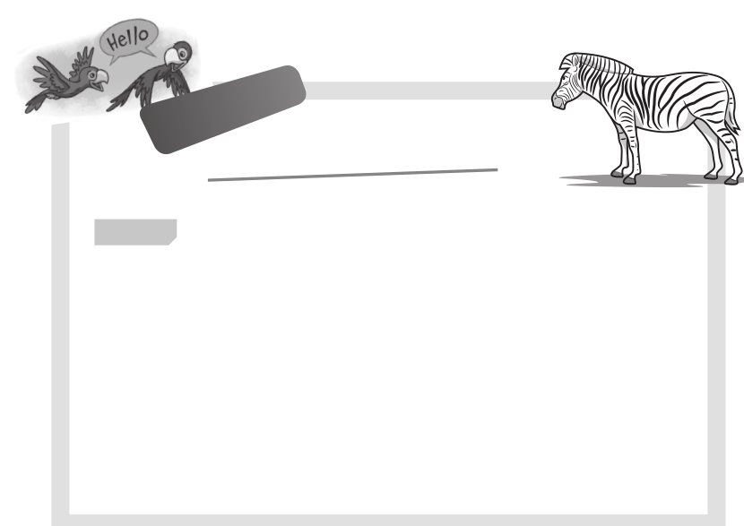

**TOEFL**

**Primary**

5

Reading

1 **Read the quiz and answer the quiz questions. Circle A, B or C.**

**Quiztime!**

**Test how much you know**

**about animals!**

Example

I have four legs and a tail. I’m not small. I’m friendly. I’m walking with my family now. What am I?

1 I have wings and feathers. I am colorful and I can talk. I’m flying

free in the jungle now. What am I?

2 I have a long tail. I like playing in the trees and I like bananas. I

can’t talk, but I’m clever. What am I?

3 I have four legs and I’m big. People can ride on me, but I’m not very fast. I live in hot, dry places. I’m carrying some food and water now. What am I?

Example A I’m a mouse.

B I’m a dog.

C I’m a tiger.

1 A I’m a parrot.

B I’m a penguin.

C I’m a monkey.

2 A I’m a snake.

B I’m a monkey.

C I’m a parrot.

3 A I’m a zebra.

B I’m a horse.

C I’m a camel.

Family and Friends Special Edition Grade 5 Assessment and Resource Portfolio Unit 5

**27**

© Oxford University Press

Permission granted to reproduce for instructional use.

**TOEFL**

**Primary**

**Reading**

2 **Read the postcard and answer the questions. Circle A, B, or C.**

Hi Clara!

How are you? I’m at the beach on vacation. I’m in Phan Thiet. The weather is sunny and the sea is blue. It’s very clean and beautiful here. I’m wearing my sunglasses and a big hat. I look good! I’m sitting

on the beach, reading comics and writing postcards. My sister and brother are swimming in the sea. Every day on vacation we go swimming in the sea. I like snorkeling and the water isn’t polluted. I can see lots of colorful fish. Yesterday, I saw a dolphin! We are staying here for one week in a hotel. We can eat lots of fish and seafood. I love it here! From Mi

Clara Taylor 7836 North Drive

Washington DC 20008

USA

Example

Who is writing the postcard?

A Clara is writing the postcard.

B Mi is writing the postcard.

C Mrs. Taylor is writing the postcard.

4

Where is Mi?

A She’s on vacation at the beach in Phan Thiet.

B She’s in the sea in Phan Thiet.

C She’s at a seafood restaurant in Phan Thiet.

5

What is Mi doing?

A She’s swimming and snorkeling in the sea.

B She’s writing postcards, reading comics and sitting on the beach.

C She’s eating fish and seafood at a restaurant.

6

How is Phan Thiet?

A The sea is blue but the weather isn't nice.

B The beach is clean, but the sea is polluted.

C The beach and the sea are clean.

Family and Friends Special Edition Grade 5 Assessment and Resource Portfolio Unit 5

**28**

© Oxford University Press

Permission granted to reproduce for instructional use.

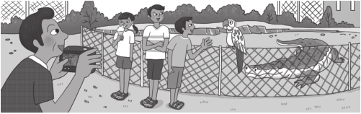

**TOEFL**

**Primary**

**Reading**

|  |  |
| --- | --- |
| 3 **Look at the picture and read.**  Today is Bao’s birthday. He is having a fun day at Saigon Zoo with his family. Bao is with his  older brother and his younger sister. Bao’s Dad is there at the zoo, too. They animals. His favorite animals are  Bao and his family can’t see the Bao’s Dad is taking a photo of the  crocodile is sleeping. They aren’t scared! bird and it’s very friendly. Bao’s sister want to see the elephants. Bao wants |  |
| all love going to the zoo. Bao likes looking at the  monkeys. They are funny but they are inside today.  monkeys today.  children. They are standing near the crocodile. The  The boys are looking at a parrot. It’s a pretty is eating ice cream. That’s her favorite. Next, they to ride on an elephant on his birthday! |

**Read and answer the questions. Circle A, B, or C.**

Example

Where are they?

A They are at the zoo.

B They are at the park.

C They are in the yard.

7

Who likes going to the zoo?

A Bao and his family like going to the zoo.

B Only Bao likes going to the zoo.

C Bao’s family like going to the zoo, but Bao doesn’t.

8

Can Bao see his favorite animals today?

A No, he can’t see them. They’re sleeping.

B Yes, he can. He can see them inside.

C No, he can’t see them. They’re inside.

9

Are the children scared of the crocodile?

A Yes, they are. They are standing near it.

B No, they aren’t. They’re not standing near it.

C No, they aren’t. It’s sleeping.

10 What does Bao want to do on his birthday?

A He wants to see the parrot.

B He wants to ride on an elephant.

C He wants his favorite ice cream.

Family and Friends Special Edition Grade 5 Assessment and Resource Portfolio Unit 5

**29**

© Oxford University Press

Permission granted to reproduce for instructional use.

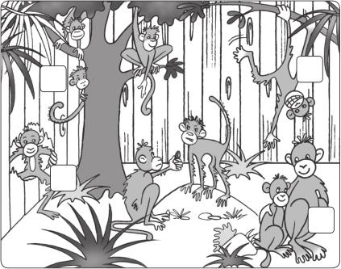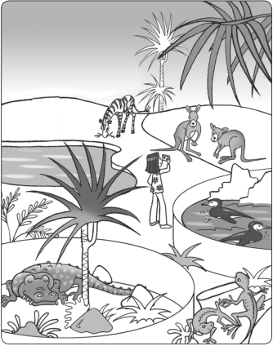

5

**Worksheet** Extra writing

1 **Look and match. Write the words.**

**1**

**2**

scared free funny kind

**1** That monkey is scared .

**2** Ha ha! That monkey is .

**3** That monkey is .

**4** **4** Look! That monkey is .

**3**

2 **Look and write questions and answers.**

**1** penguins / swim?

Are the penguins swimming? Yes, they are.

**2** zebra / run?

Is the zebra running? No,

**3** girl / take a photo?

**4** lizards / eat?

**5** crocodile / sleep?

**What’s your favorite animal?**

Write a sentence and draw the animal.

Family and Friends Special Edition Grade 5 Assessment and Resource Portfolio Unit 5

**30**

© Oxford University Press

Permission granted to reproduce for instructional use.

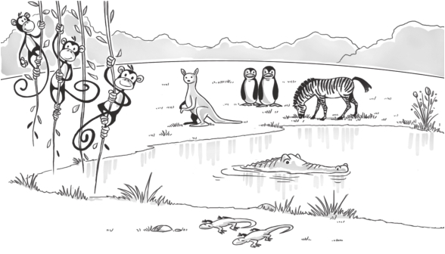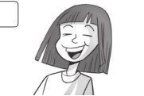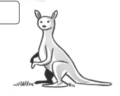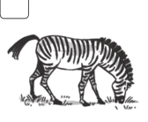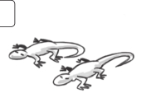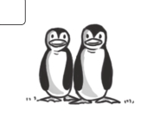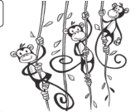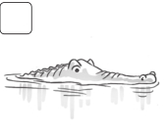

**Test** 5 Unit test

1 **Write** **or** **.** **/27**

**1** penguin 

**2** monkey

**3** camel

**4** kangaroo

**5** crocodile

**6** lizard

**7** lion

**8** zebra

2 **Circle.** **/73**

**1** **2** **3** **4**

funny / sorry kind / scared sorry / funny funny / scared

3 **Underline the correct words.**

**1** Is the zebra eating?

Yes, **it is** / **it’s** / **it’re**.

**2**

Is the kangaroo jumping?

No, **it aren’t** / **it not** / **it isn’t**.

**/5**

**3**

**5**

Are the penguins flying?

No, **they isn’t** / **they aren’t** / **they not**.

Is the crocodile swimming?

Yes, **it’s** / **it swimming** / **it is**.

**4**

**6**

Are the lizards sleeping?

Yes, **they are** / **they’re** / **they’s**.

Are the monkeys eating?

No, **they aren’t** / **they not** / **they not are**.

Family and Friends Special Edition Grade 5 Assessment and Resource Portfolio Unit 5

**31**

/15

© Oxford University Press

Permission granted to reproduce for instructional use.